Watershed Management

Introduction

Double Bayou
The East and West Forks of Double Bayou run through the heart of mid Chambers County and have served witness to some key developments in Texas history, including the founding in 1847 of what became the 26,000-acre JHK Ranch along the East Fork; the birth of a future Texas governor in 1875 along the West Fork (Ross Shaw Sterling); the move of the Chambers County seat to Anahuac in 1907; and the development of the Anahuac oil field in the 1930s.
Today, the lands and waters in and around Double Bayou provide a snapshot of the much-prized rural Chambers County life: rice farming, cattle grazing, oil production, small town and country living, industry and commercial navigation, sailing, paddling, crabbing, recreational fishing, and wildlife watching. In addition, the waters of Double Bayou drain into Trinity Bay, just up-current from the largest oyster harvesting operation in Texas.
This document seeks to describe the relationship between the lands and waters of Double Bayou, and what stakeholders – those who live, work, and/or play in the watershed – have done to plan for voluntarily improvements in the health and function of Double Bayou.

Watersheds

What is a Watershed?
The simple definition of a watershed is the area of land that catches rain and drains the runoff into a stream, marsh, bayou, river, lake or ocean. Watersheds can be large or small – from one that is as small as the land area that drains to a local stream in a neighborhood, to those that drain into a major river like the Mississippi River, or into a bay and, ultimately, the ocean.
Each watershed can be part of a larger watershed (Figure 1-1 Double Bayou Watershed System). Smaller watersheds that are part of a larger one may be called a sub-basin or subwatershed. Watershed boundaries often cross municipal, county and state boundaries because they are determined by physical geography and not by political boundaries.
Everyone lives in a watershed. Because a water body “catches” the runoff from land in its watershed, the water quality and the water quantity in the water body is affected by what we do on the land. The overall function and health of the watershed and water body is the result of these cumulative effects.
The watershed of Double Bayou is an area of approximately 94 square miles that starts in southern Liberty County and drains to the East and West Forks of Double Bayou, which join at the southern part of the watershed and discharge into Trinity Bay at Oak Island.

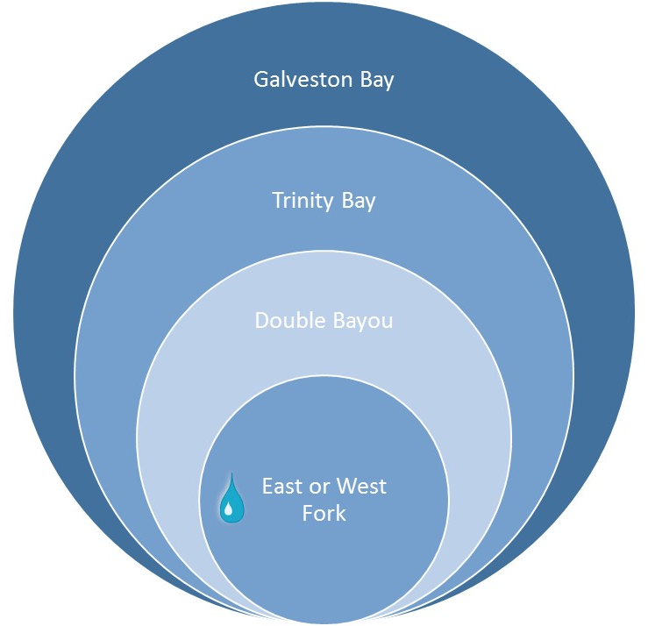
Watersheds and Water Quality
Figure ‎1-1 Double Bayou Watershed System
Activities in the watershed can impact water quality. Water quality describes the chemical, physical and biological characteristics of the water. Water quality criteria, or thresholds, are often established to evaluate how suitable water is for particular uses. Substances that make water unsuitable for its desired uses are termed pollutants, or contaminants. Pollutants may be man-made, or they may be natural, but in harmful concentrations.
Sources that can contribute to water quality include two main categories – point and nonpoint source pollution. Runoff from the land to a stream starts as rainfall flowing over agricultural, urban, residential, industrial, and/or undeveloped areas in a watershed. This runoff can carry with it pollutants washed from the surrounding landscape. This type of pollution, coming from diffuse sources, is called nonpoint source pollution. Examples of different types of nonpoint source pollution include fertilizers running off of residential lawns or from agricultural fields, pet waste in urban runoff, and wastes from wildlife, feral hogs, or livestock. Nonpoint source pollution can be harder to manage since it is not a single source.
On the other hand, point source pollution, as the name suggests, comes from a single source released directly into a water body, such as a pipe or other outlet. Point source pollution is subject to regulation by permit. Discharges from wastewater treatment facilities are an example of point source pollution.

Water Quality Standards

Meeting Water Quality Standards
The Clean Water Act (CWA) required that all states establish standards for measuring the health of surface water bodies. The states must develop standards that describe how the water bodies are used, establish water quality criteria and develop a program to monitor the water quality. The Texas Commission on Environmental Quality (TCEQ) is charged with managing the quality of water resources in Texas, including establishing the State’s water quality standards and setting water quality criteria.
TCEQ evaluates surface water quality for the State through monitoring, laboratory analysis and data analysis. Stream segments are evaluated based on a seven-year assessment period for the various established criteria. Every two years, the TCEQ must report to the Environmental Protection Agency (EPA) the extent to which the State’s water bodies are meeting surface water quality standards. The Texas Integrated Report is developed by the TCEQ and submitted to the EPA and describes the status of all surface water bodies in Texas according to these standards. The CWA 303(d) list, also known as the impaired waters list, identifies all surface water bodies that do not meet the established criteria (i.e., are impaired).
As part of its standards-setting process, TCEQ established the designated uses for Double Bayou’s water quality as: Aquatic Life; Primary Recreation / Swimming; General; and Fish Consumption (Figure ‎1-2 West Fork Double Bayou recreation). These designated uses, in turn, require certain levels of water quality.
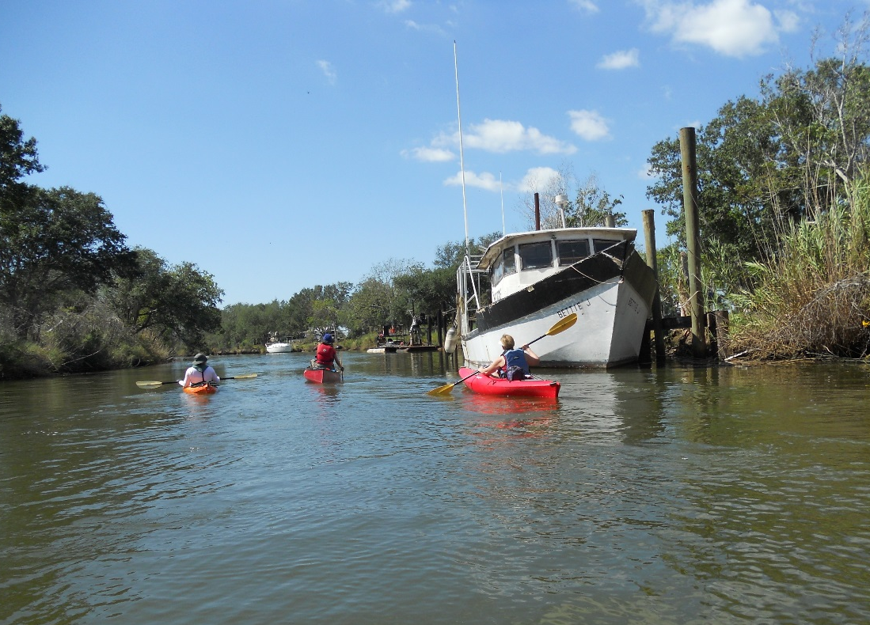
Figure ‎1-2 West Fork Double Bayou recreation

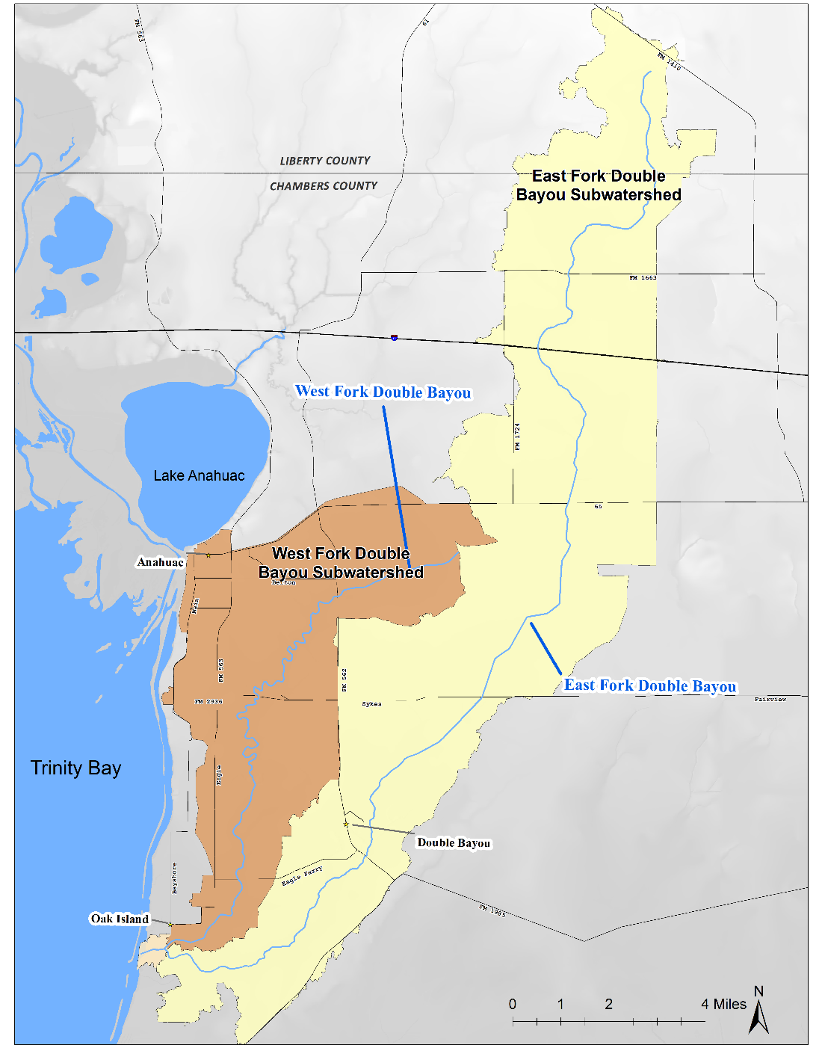
A Watershed Approach to Water Quality Management
Figure ‎1-3 Double Bayou Watershed

Watershed Approach
Since watersheds are an integrated system of land and water, planning for the improved health of a stream benefits from looking at its watershed system as a whole. By taking a watershed approach to water quality management – rather than approaching it by political entities – the potential pollution sources can be better identified and evaluated, not just those that originate in one particular political entity, and yet perhaps affect another entity downstream. A watershed approach also helps better identify the potential methods for addressing the water quality issues. A key reason for the success of a watershed approach is that all of the stakeholders in a watershed can be involved in developing a plan to protect and improve local water quality, bringing together their collective knowledge, experience, expertise, and commitment. For these reasons, state and federal agencies have embraced the watershed approach.
In Texas, the TCEQ manages programs to prevent urban nonpoint source pollution, and the Texas State Soil and Water Conservation Board (TSSWCB) manages programs to prevent agriculture/silvicultural nonpoint source pollution.

Watershed Protection Planning for Double Bayou
Using the watershed approach, the TSSWCB has supported the development of Watershed Protection Plan for Double Bayou. The idea of a Watershed Protection Plan is to work with local stakeholders to improve water quality through voluntary participation. A stakeholder is anyone who lives, works, or has an interest within the watershed. Stakeholder involvement is critical for selection, design and implementation of management measures that improve water quality. Stakeholder stewardship guides successful Watershed Protection Plan development and implementation.
The goal of the Double Bayou Watershed Protection Plan is to provide a roadmap to improve the water quality in Double Bayou through a voluntary, collaborative approach that uses stakeholder ideas written into the Plan. The Double Bayou Watershed Protection Plan presents the current state of the watershed, discusses water quality sampling efforts and results, identifies causes and sources of pollution as identified by stakeholders, outlines stakeholder recommended management measures, and includes specifications for the technical and financial framework required for implementation. To increase the likelihood of successful implementation, including opportunities for federal Clean Water Act grants, the Double Bayou Watershed Protection Plan includes key steps developed in EPA’s Elements of Successful Watershed Plans.

