State of the Double Bayou Watershed

Double Bayou Watershed Overview

Double Bayou landscape
The Double Bayou watershed is located on the Upper Texas Gulf Coast and is part of the Galveston Bay watershed (Figure ‎2-1 Double Bayou watershed). Situated in the eastern portion of the Lower Galveston Bay, it is comprised of two main subwatersheds: East Fork and West Fork, which are also the primary waterways in the watershed. The Double Bayou watershed drains directly into the Trinity Bay system and ultimately into Galveston Bay. The majority (93%) of the watershed lies within Chambers County, Texas. The remaining 7% of the watershed is located in Liberty County, Texas. The Double Bayou watershed drains 98 square miles (61,445 acres) of predominantly rural and agricultural landscape. However, several residential centers are located in the watershed.
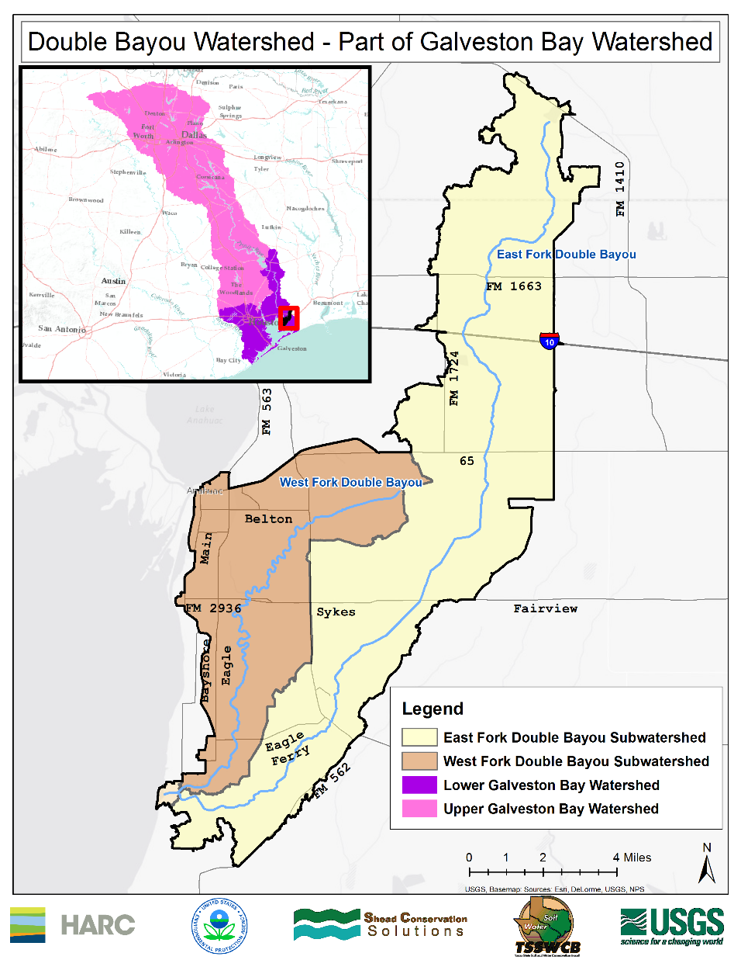
Figure ‎2-1 Double Bayou watershed
The City of Anahuac, Texas is located on the Trinity River and the northeast bank of Trinity Bay. This rural community is the largest contiguous area of developed land in the watershed. Anahuac has a total area of 1,344 acres (2.1 square miles) and is nine feet above sea level (District 2013). Anahuac is the Chambers County seat, with a 2010 population of 2,243. Much of the middle portion of Chambers county drains into Double Bayou. The unincorporated community of Oak Island is identified by the U.S. Census as a designated place. Oak Island is located at the confluence of the East and West Forks of Double Bayou and Trinity Bay. Approximately half of Oak Island is located in the Double Bayou Watershed. A third smaller community in the watershed is called Double Bayou and is located near the East Fork and FM 562.

Double Bayou climate
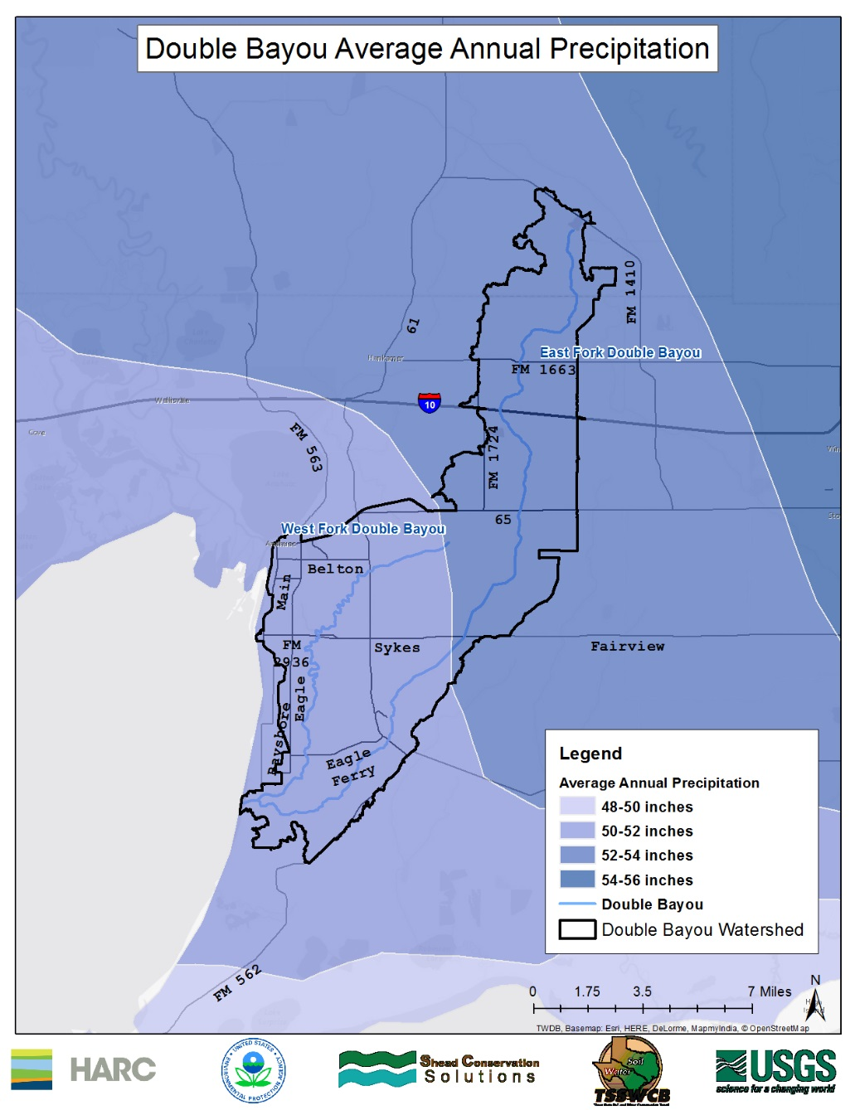
The climate of the Double Bayou watershed is Humid Subtropical, defined by hot humid summers and mild winters. The annual peak of rainfall typically occurs in July. However, the peak summer rainfall is dependent on the hurricane season and can reach a maximum in September during hurricane-intensive years. Typically, the average annual rainfall for the southeastern portion of the watershed ranges from 50-52 inches, while the northern portion ranges from 52-54 inches (Figure ‎2-2 Double Bayou watershed average annual precipitation). The total annual rainfall in the Double Bayou watershed during 2014 was 43.3 inches. The average temperature ranges from a high of 92˚F in August to a low of 42˚F in January. The absolute high temperature for the calendar year 2014 was 97˚F and the lowest temperature was 20˚F.
Figure ‎2-2 Double Bayou watershed average annual precipitation
The East Fork of Double Bayou in Liberty County originates slightly south of FM 1410 (Figure ‎2-1 Double Bayou watershed). The entirety of the East Fork of Double Bayou follows a relatively straight channel southwest towards Trinity Bay for a total of 27 miles. The only named tributary, Chimney Bayou, joins with the East Fork of Double Bayou slightly north-east of FM 562 and Eagle Ferry Road. Originating just south of HWY 65 and FM 1724, the West Fork of Double Bayou is approximately half the length (14.45 miles) of the East Fork and is characterized by a meandering channel (Figure ‎2-1 Double Bayou watershed). The lower portions of both bayous are tidally influenced. The two form their confluence a quarter of a mile before joining Trinity Bay at Oak Island, Texas (Figure ‎2-3 Confluence of East and West Forks tidal waters at Job Beason Park). The bayous’ estuary, Trinity Bay, is designated as unclassified oyster waters and as a classified estuary (see Chapter 4 for discussion on classification designations). According to the TCEQ, Trinity Bay is 122.86 square miles. In addition to the natural waterways, there are many channelized water-delivery canals and drainage ditches in the watershed.
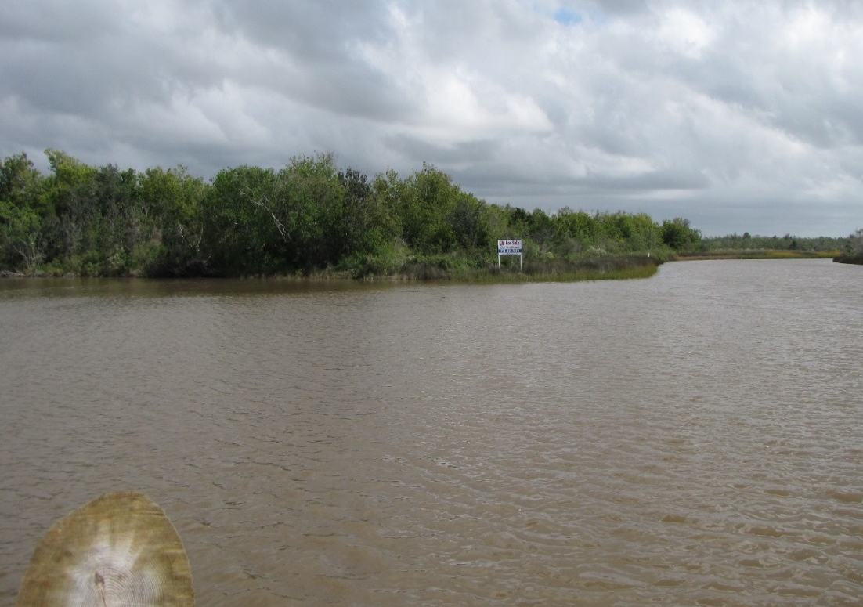
Figure ‎2-3 Confluence of East and West Forks tidal waters at Job Beason Park
The natural drainage patterns in the Double Bayou watershed have been highly altered by an extensive network of waterways for drainage and agriculture. For example, the Anahuac Ditch is classified as an unimpaired, perennial freshwater stream (see Chapter 4 for a discussion on classifications) that is 2.81 miles in length, which flows south from Belton Lane in the town of Anahuac to its confluence with the West Fork of Double Bayou just upstream of FM 2936 (Sykes Road). The expansive canal and ditch system in the watershed is an attempt to address the poorly drained hydrology of the watershed. The Double Bayou watershed’s natural drainage is further characterized by having a shallow water table and a weakly dissected alluvial plain with deep saline soils (HARC 2011).

Geography

Ecoregion
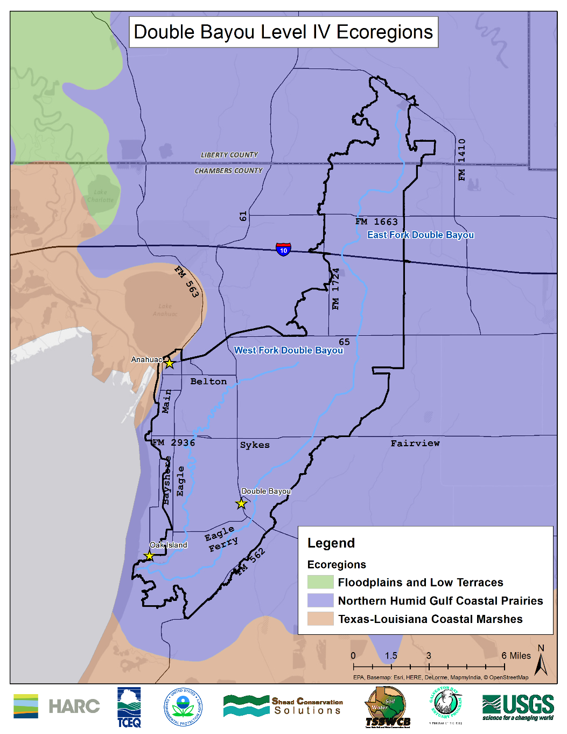
The entire Double Bayou watershed lies within the Northern Humid Gulf Coastal Prairies ecoregion (Figure ‎2-4 Level Four Ecoregions of Double Bayou). The original vegetation of the Northern Humid Gulf Coastal Prairies ecoregion was mostly grasslands with a few clusters of oaks (oak mottes or maritime woodlands). Little bluestem (Schizachyrium scoparium), yellow indiangrass (Sorghastrum nutans), brownseed paspalum (Paspalum plicatulum), gulf muhly (Muhlenbergia capillaris), and switchgrass (Panicum virgatum) were the dominant grassland species. There is some cropland, rangeland, pasture, or urban land uses (Griffth, Bryce et al. 2007). Some loblolly pine (Pinus taeda) forest occurs in the northern part of the region. Live oak (Quercus virginiana), bald cypress (Taxodium distichum), pine (Pinus sp.) and cedar (Cedras sp.) trees are common accompanied by hardwood species on riparian corridors (Figure ‎2-5 Riparian corridor along West Fork Double Bayou) (District 2013).
Figure ‎2-4 Level Four Ecoregions of Double Bayou
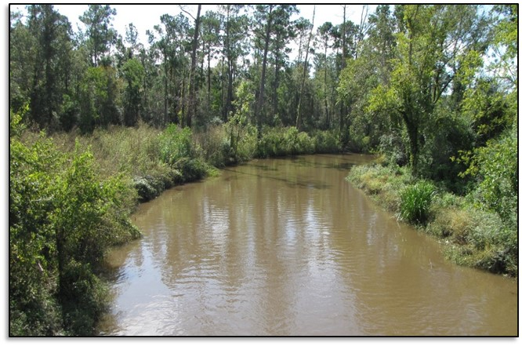
Figure ‎2-5 Riparian corridor along West Fork Double Bayou

Soils
Within the Double Bayou watershed, there are different soils including the higher Lissie Formation and the lower Beaumont Formation (both of Pleistocene age). The Lissie Formation has lighter colored soils, mostly Alfisols, with sandy clay loam surface texture, while darker, clayey soils associated with Vertisols are typical of the Beaumont Formation (Griffth, Bryce et al. 2007). The soils remain homogenous throughout the watershed and are mostly fine-textured: clay, clay loam, or sandy clay loam.

Topography
Typical for the Northern Humid Gulf Coastal Prairies ecoregion, the northern portion of the watershed has the highest elevation at 22.7 meters (about 74.5 feet). The topography of this flat coastal prairie gently slopes south towards Trinity Bay and ends at an elevation of -2.8 meters (about 9.2 feet) below sea level for a change of 25.5 meters (about 83.6 feet) in elevation (across approximately 20 miles). The average elevation within the Double Bayou watershed is just over 6 meters (about 19.7 feet) above sea level.

Fish and Wildlife

Wildlife and Habitat
Common fish species in Double Bayou include the Western mosquitofish (Gambusi affins), bluegill (Lepomis macrochirus), longear sunfish (Lepomis megalotis), spotted sunfish (Lepomis punctatus), warmouth (Lepomis gulosus) and the bay anchovy (Anchoa mitchilli). Less common fish species include the pirate perch (Aphredoderus sayanus), Ppgnose minnow (Opsopoeodus emiliae) and the hogchocker (Trinectes maculatus). Largemouth bass (Micropterus salmoides) have been reported and represent a recreational opportunity in the bayous. Common species of birds around Trinity Bay include the reddish egret (Egretta rufescens), roseate spoonbill (Platalea ajaja) and white-tailed hawk (Buteo albicaudatus) (HARC 2011)(data from TPWD).
Other wildlife that is native to the Double Bayou watershed include coyote (Canis latrans), river otter (Lutra canadensis), swamp rabbit (Sylvilagus aquaticus), American alligator (Alligator mississippiensis), Texas blind snake (Leptotyphlops dulcis), Gulf coast toad (Bufo nebulifer) and diamondback terrapin (Malaclemys terrapin) (Turco 2006-07).
In-stream cover is ample along the bayous and primarily consists of woody debris, root wads, macrophytes, algae and overhanging vegetation (Error! Reference source not found.). Analysis of the riparian corridor of Double Bayou shows approximately 32% canopy cover on East Fork and 39% canopy cover on West Fork (calculated using approximately 20 meter (65 feet) riparian corridor buffer around the bayous from 2011 satellite imagery data). The amount of cover varies widely by reaches along the bayous, depending both on whether the floodplain remains forested and on how the riparian area is managed.
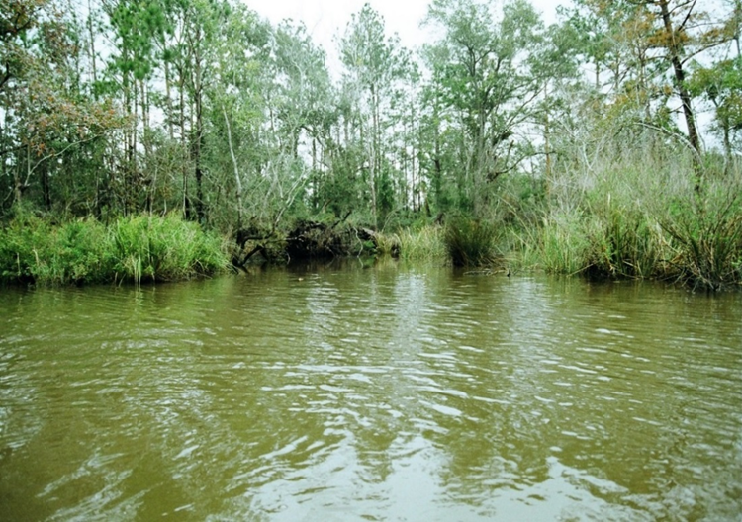
Figure ‎2-6 Riparian habitat in Double Bayou

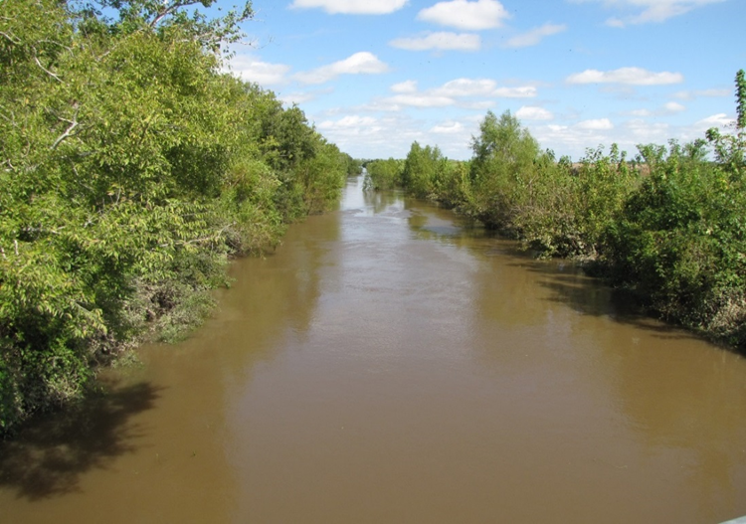
Figure ‎2-7 Overhanging vegetation East Fork Double Bayou

Invasive Exotic Species
Nonnative invasive species are also in the watershed, such as feral hogs (Sus scrofa) (also called wild pig), Chinese tallow (Triadica sebifera), Chinese privet (Ligustrum sinense), water hyacinth (Eichhornia crassipes), giant salvinia (Salvinia molesta) and alligator weed (Alternanthera philoxeroides).
Feral hogs are opportunistic generalists that exhibit a high affinity for riparian habitats (Figure ‎2-8 Feral hog in coral trap). Thus their potential to negatively impact the watershed is high. Stakeholders have observed that the feral hog population has been increasing in the watershed. Stakeholder estimates of the feral hog population in the watershed vary, from approximately 1,300 to at least 1,500 individuals. Feral hogs lack sweat glands, causing them to congregate in and around waterways, to wallow and keep cool. Due to the extensive network of natural and channelized waterways, canals and ditches, the feral hogs can traverse the watershed and spread rapidly.
Research suggests that the feral hog’s reproductive capabilities are more than 4 times higher than that of native ungulates such as the white-tailed deer. Sows can become reproductively capable at 6 to 10 months of age and have the potential for bi-annual recruitment (i.e. the rate at which individuals are added to the feral hog population through births and/or immigration) of 4-6 piglets annually – both of which are factors in rapidly increasing feral hog populations. With few natural predators, feral hog populations have the opportunity to grow virtually unregulated in the wild (Tyson 2015).
Due to their affinity for water, feral hogs tend to deposit bacteria-laden fecal waste directly into the waterways of the watershed. Their unrelenting appetite also has a negative impact on future seed recruitment and therefore seed abundance of riparian oak (Quercus sp.) and hickory (Carya sp.) trees. Feral hogs damage the native riparian plant communities and compete with native wildlife for food sources. Additionally, feral hogs cause an average of $52 million in damage annually to Texas agriculture industries (Timmons, Alldredge et al. 2012).
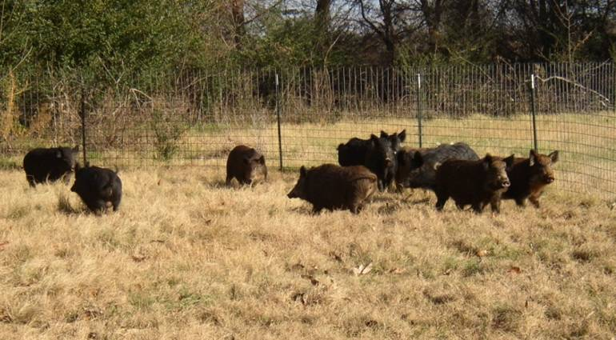
Figure ‎2-8 Feral hog in coral trap
The Chinese tallow tree (Sapium sebifera) and the Chinese privet (Ligustrum sinense) have invaded large areas of the watersheds. The Chinese tallow tree is considered the most established invasive species in the Lower Galveston Bay watershed (Chilton, Robinson et al. 2011). The Double Bayou watershed is particularly vulnerable to the Chinese tallow tree because this tree thrives in the coastal prairie wetlands and ample riparian stream habitat provided by the bayous. The Chinese tallow tree is toxic to livestock, wildlife and humans, which increases the risk of managing this invasive species (health concerns with handling or burning). The Chinese privet is also an aggressive invasive species that can establish rapidly in and around waterways and fence lines. Both species outcompete native riparian plant communities for space, sunlight and nutrients.
In addition to terrestrial invasive plant species, aquatic invaders directly impact Double Bayou waterways. Water hyacinth (Eichhornia crassipes) is considered to be the most detrimental nonnative aquatic plant species (Figure ‎2-9 Water hyacinth East Fork Double Bayou). It can spread quickly on the surface of waterways, dominating native submerged vegetation. These large aquatic mats inhibit light and oxygen diffusion and impede water movement, leading to low dissolved oxygen levels. The low dissolved oxygen can kill native populations of fish (Chilton, Robinson et al. 2011).

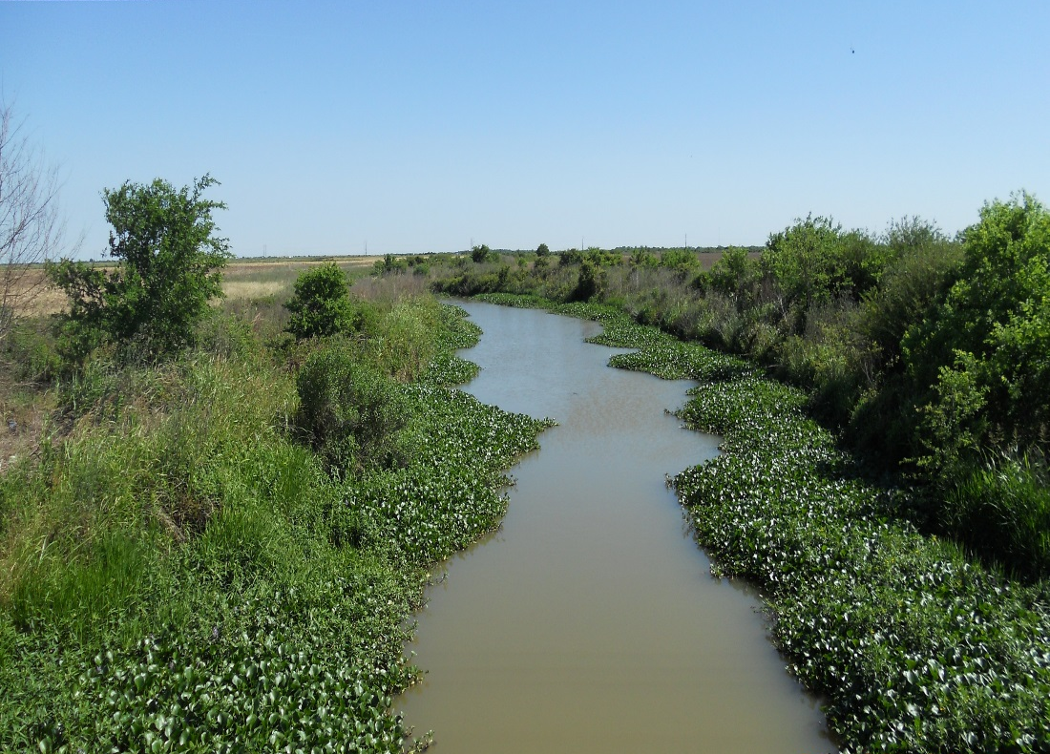
Figure ‎2-9 Water hyacinth East Fork Double Bayou
In addition, giant salvinia (Salvinia molesta) replaces native forage and is regarded as the second most harmful aquatic invasive species behind water hyacinth. Alligator weed (Alternanthera philoxeroides), another invasive species, can out compete aquatic and terrestrial native vegetation and reduce the recreational quality of a waterway. Alligator weed also has the potential to be associated with low dissolved oxygen concentrations. These aquatic invasive species increase the rate of evapotranspiration and reduce the amount of water retained in bayous (Chilton, Robinson et al. 2011).

Parks and Recreational Lands
There are three municipal parks located in the Double Bayou watershed, totaling 87 acres. The largest is Double Bayou Park, which is 37.1 acres, and is located near the intersection of FM 562 and Eagle Ferry Road. The park provides birding, fishing, picnicking and camping opportunities. The second largest park is Fort Anahuac Park (36.8 acres). This historic park is located on South Main Street just south of Lake Anahuac and provides ample recreational opportunities, including fishing, birding towers and nature trails. The third park is Job Beason Park (13.1 acres), which is located at the confluence of the East and West forks of Double Bayou. Job Beason Park’s unique location provides an interesting opportunity to highlight the ecology at the confluence of both bayous and Trinity Bay.

Human History
PLACEHOLDER: COMING SOON

Land Use

Land Cover
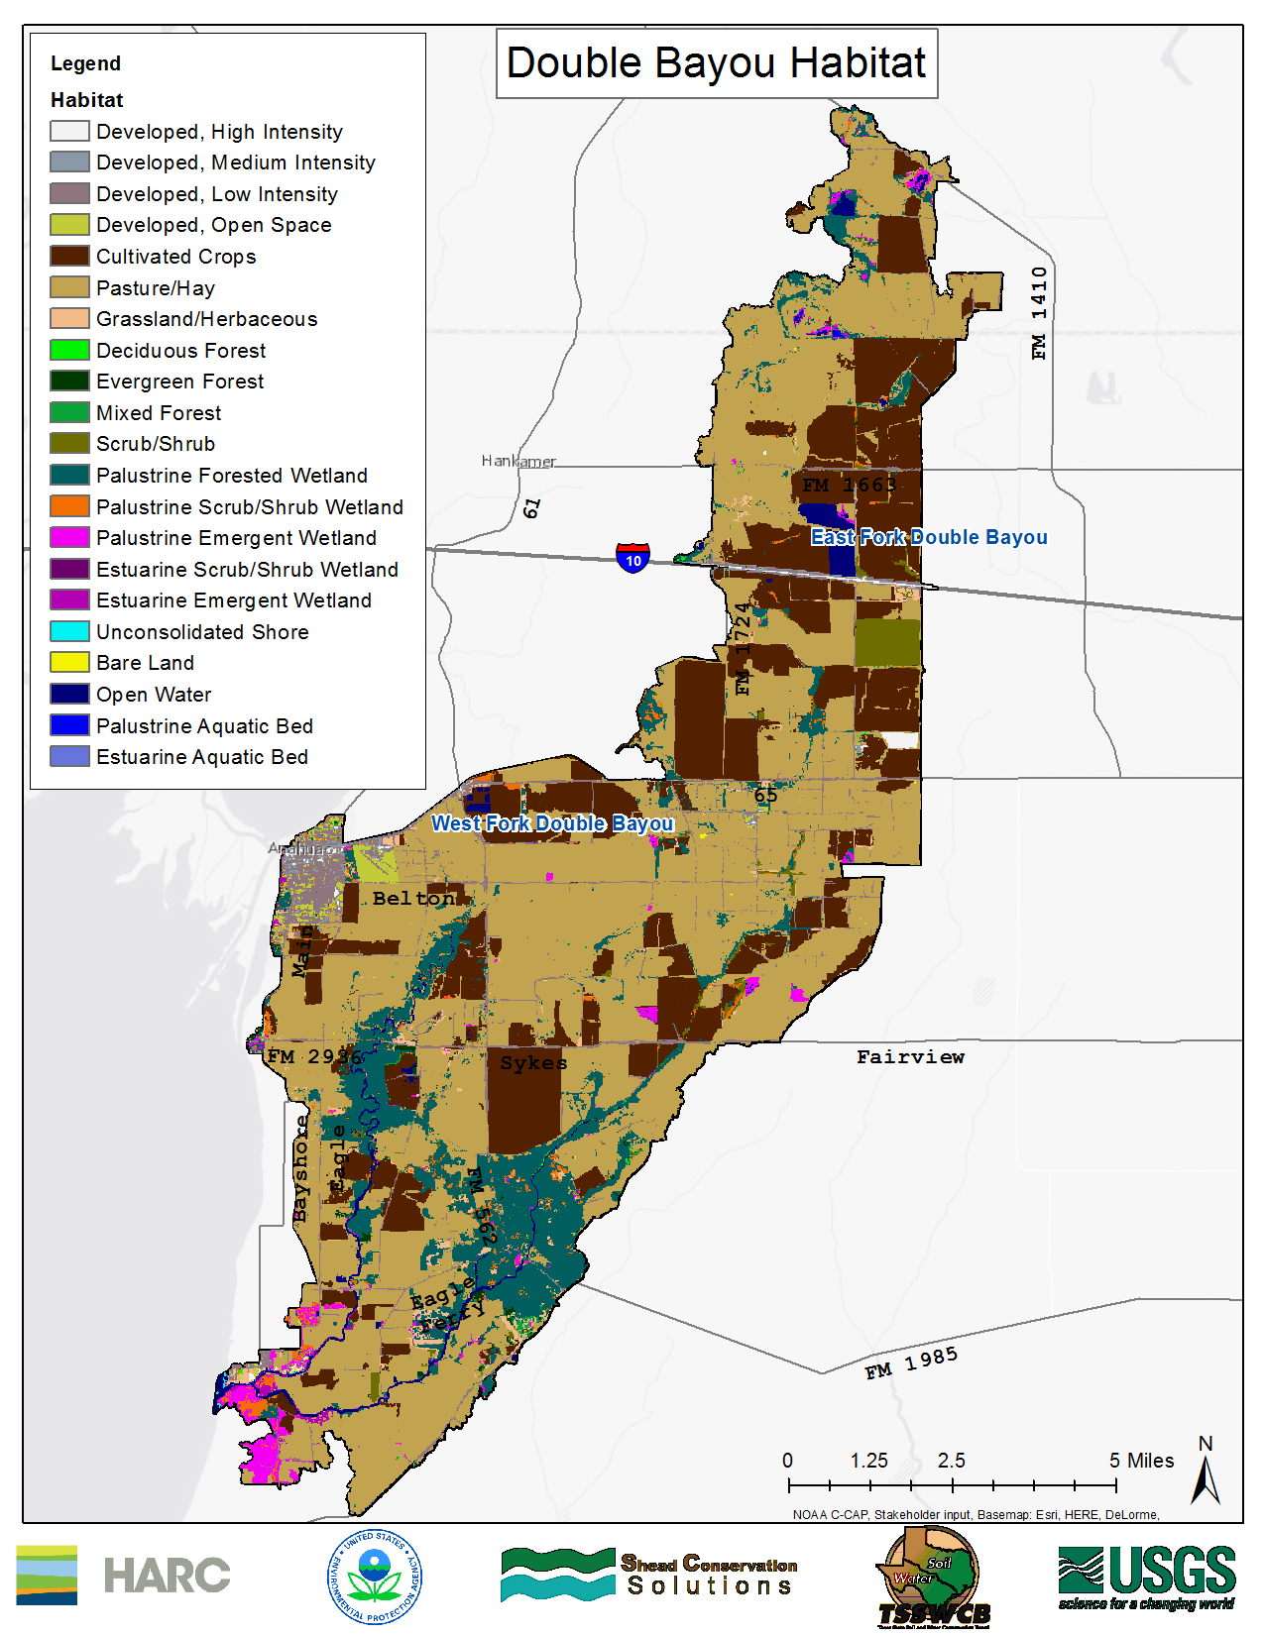
The National Oceanic and Atmospheric Administration (NOAA) Coastal Change Analysis Program (C-CAP) 2010 data for the Double Bayou watershed is shown below (Figure ‎2-10 Land Cover and habitat in Double Bayou watershed). The most abundant land use/land cover class in the Double Bayou watershed is Pasture/Hay (34,853 acres), while the least dominant land use/land cover class is Estuarine Aquatic Bed (about 1.5 acres).
Figure ‎2-10 Land Cover and habitat in Double Bayou watershed
A dominant habitat land cover in the Double Bayou Watershed is the Palustrine wetland system; this is not further defined by subsystems, but is represented by four classes of wetlands in the watershed; Palustrine Forested Wetland, Palustrine Emergent Wetland, Palustrine Scrub-Shrub Wetland and Palustrine Aquatic Bed.
Palustrine Forested Wetlands are typically tidal and nontidal wetlands that are dominated by trees that are greater than or equal to 5 meters in height, shrubs and persistent emergent vegetation. Palustrine Forested Wetlands are considered to be wetlands that occur in tidal areas where the salinity is below 0.5% (Cowardin, Carter et al. 1979). The majority of the Palustrine Forested Wetlands in the Double Bayou watershed are located along the East and West Forks and form some of the only remaining riparian corridor communities.
Palustrine Emergent Wetlands differ from forested wetlands because they include mosses, lichens and vascular plants. Emergent Wetlands are further characterized by having erect, rooted herbaceous hydrophytes and are dominated by perennial plants. Palustrine Scrub-Shrub Wetlands are defined by areas that contain woody vegetation less than 5 meters in height and can consist of all water regimes except sub-tidal. Finally, Palustrine Aquatic Bed Wetlands contain plants that grow mainly on or below the surface of the water the majority of the growing season and have permanently standing surface water (Cowardin, Carter et al. 1979).
The present Estuarine wetland subsystems include two Intertidal and one Subtidal system in the watershed. The Subsystems can be further classified as Estuarine Emergent Wetland, Estuarine Scrub-Shrub Wetland and Estuarine Aquatic Bed habitat. However, Estuarine wetlands total only 114 acres of the Double Bayou watershed and therefore are not dominant on the landscape.
Land Cover/Land Use Type | Acres | % of Total Watershed Acres
Pasture/Hay | 34,853 | 57.4%
Cultivated Crops | 12,993 | 21.4%
Palustrine Forested Wetland | 6,132 | 10.1%
Developed, Low Intensity | 2380 | 3.9%
Palustrine Emergent Wetland | 781 | 1.3%
Grassland/Herbaceous | 684 | 1.1%
Palustrine Scrub/Shrub Wetland | 669 | 1.1%
Open Water | 653 | 1.1%
Developed, Open Space | 380 | 0.6%
Scrub/Shrub | 374 | 0.6%
Developed, Medium Intensity | 267 | 0.4%
Evergreen Forest | 147 | 0.2%
Mixed Forest | 146 | 0.2%
Estuarine Emergent Wetland | 111 | 0.2%
The following classes comprise 30 acres or less (0.05% or less) per category: Bare Land, Deciduous Forest, Palustrine Aquatic Bed, Unconsolidated Shore, Estuarine Scrub/Shrub Wetland and Estuarine Aquatic Bed
Table ‎2-1 Double Bayou Land Cover/Land Use type
Considering the small percentages of certain land cover classes present in the Double Bayou watershed, and in an interest by the stakeholders to streamline the land cover for subsequent analysis, modeling and management measure decision processes the land cover classes were consolidated into seven categories. Stakeholders wanted to focus on groupings of vegetative heights (as opposed to soil type or wetland category) due to familiarity with placement in the watershed. Each of the land cover classes is represented in one of the seven categories (Table ‎2-2 Land Cover Class Groupings in the Double Bayou Watershed consolidated from the NOAA Coastal Change Analysis Program (C-CAP)
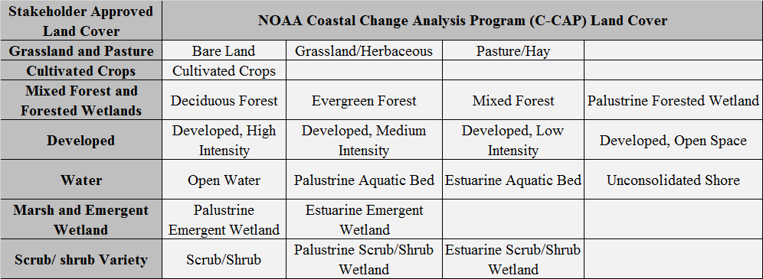
Table ‎2-2 Land Cover Class Groupings in the Double Bayou Watershed consolidated from the NOAA Coastal Change Analysis Program (C-CAP)

Geographic Task Force
The estimated watershed boundaries were determined via local knowledge of the watershed and drainage system. A United States Geologic Survey (USGS) Hydrologic Unit Code (HUC) watershed boundary was used to define a larger watershed area. Local knowledge - through several stakeholder meetings, site visits, and iterations of the boundary and land cover - was applied to better represent the Double Bayou watershed. Different flow patterns from the intricate drainage ways were reviewed by the stakeholder geographic task force and incorporated into the boundary. Stakeholder input was used to ground-truth the land cover and ensure that the ground cover of land use blocks was accurate, regarding the seven grouped categories of: Grassland/pasture, Cultivated crops, Mixed forest/ forested wetlands, Developed, Water, Marsh/Emergent Wetlands and Scrub-Shrub variety.
There was also discussion that the land cover classification data represented a “snapshot” in time. Due to the nature of crop rotations, sometimes a block of land designated as Cultivated crops one year may be Grassland/pasture the next year, as a cultivated field is left. Cattle are then moved from Grassland/pasture to Cultivated crops, and then that pasture land is once again cultivated. The stakeholders agreed that since generally the same areas are traded back and forth between cultivated and pasture, and generally these areas are adjacent or nearby (and thus likely in the same subwatershed), the finalized land cover summed up the whole land cover categories to the best extent possible.

Demographics
The smallest U.S census unit, the block level, was used to estimate the population of the watershed for each decade from 1970 to 2010 (Figure ‎2-11 Double Bayou watershed population 2000 (3,535) and 2010 (3,335)). To account for instances when a block boundary fell partially in the watershed, a ratio of block land percentage in and out of the watershed was used. According to this methodology, the 2010 Double Bayou watershed population is estimated to be 3,335 people (Table ‎2-3 Population of Double Bayou watershed and Anahuac, TX).
Year of Census | Population of Double Bayou Watershed | Percent Change of Watershed Population | Population of Anahuac, TX | Percent Change of Anahuac, TX Population
1970 | 2,299 | X | 1,881 | X
1980 | 3,117 | 26% | 1,840 | -2%
1990 | 2,923 | -7% | 1,993 | 8%
2000 | 3,535 | 17% | 2,210 | 10%
2010 | 3,335 | -6% | 2,243 | 1.5%

Table ‎2-3 Population of Double Bayou watershed and Anahuac, TX

In 1970, Anahuac had a population of 1,881 people. After a 2% decline in population the total number of residents in 1980 was 1,840. In 1990, Anahuac had a population of 1,993 individuals. A 10% increase of population occurred from 1990 to 2000 with the addition of 217 people, and a 1.5% increase occurred from 2000 to 2010 with the addition of 33 persons. The 2010 census reports that Anahuac had a population of 2,243 persons. The population by age in Anahuac was: 1,397 people between the ages of 18 and 64, 456 people between the ages of 5 and 17 years old, 246 people over 65 and 144 people under 4 years old.

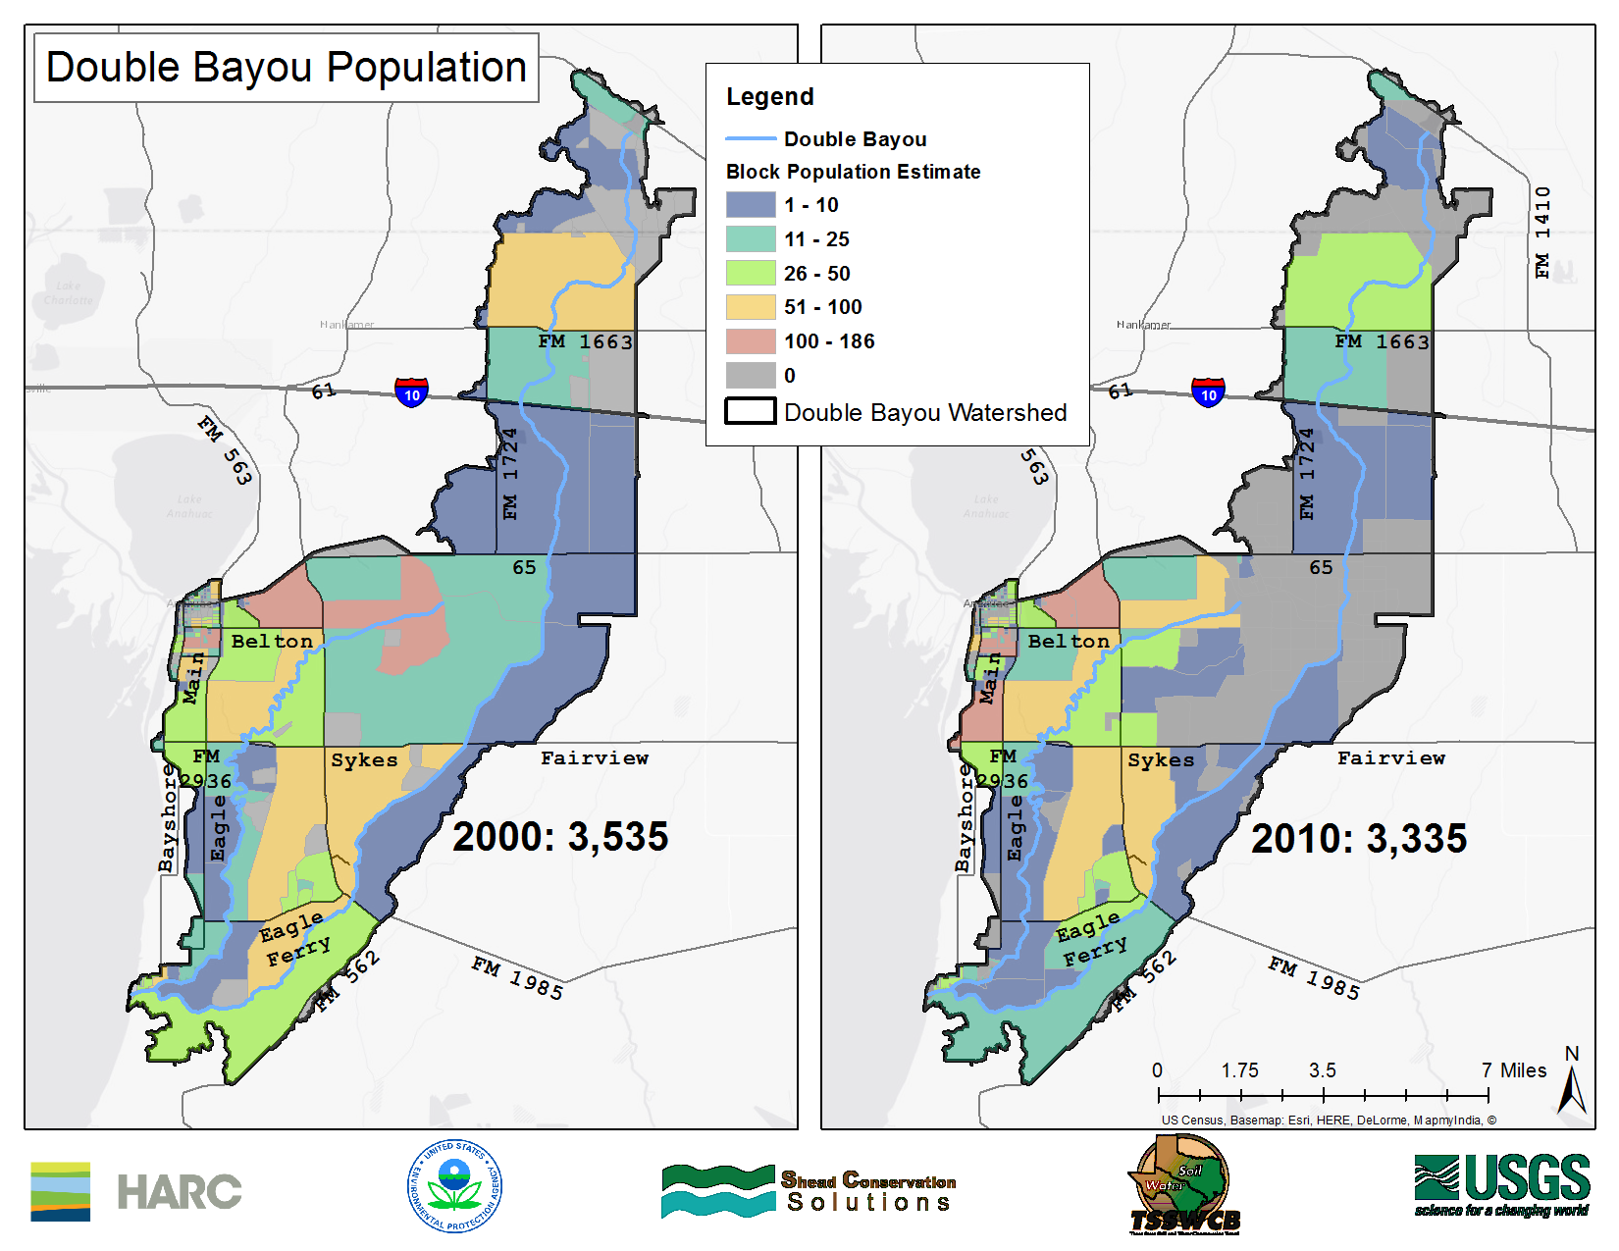
Figure ‎2-11 Double Bayou watershed population 2000 (3,535) and 2010 (3,335)

Existing Land Management Practices
The 2012 agricultural census reports that forage, including hay, haylage, grass silage and greenchop, and rice are the top crop items in Chambers County. Sorghum for grain and wheat for grain also make up a portion of the farming operations (USDA 2012). These trends are reflected in the Double Bayou watershed, where rice farming and cattle ranching are the main types of agriculture. Accordingly, predominate watershed land cover is 12,993 acres of cultivated crops (21.4%) and 34,853 acres of hay or pasture (57.4%). (Figure ‎2-12 Rice Farming along the East Fork). The presence of rice farming requires a canal and irrigation system to support operations. In 2012, the average size farm in Chambers County was 346 acres. Since 2007 there has been a 16% reduction of the average farm size in the county (USDA 2012).

Figure ‎2-12 Rice Farming along the East Fork

The City of Anahuac, the residential community of Oak Island, and pockets of oil/gas drilling and exploration activities are the largest developed areas of land cover in the watershed. The largest concentration of oil/gas wells are located south of FM 65 and FM 1724 in the historic Anahuac oil field, which centers around the Anahuac oil gathering system and pipeline operated by the Texas Petroleum Company. Natural gas pipelines are also prevalent in the watershed along with active and plugged wells. The oil/gas operations combined with the community of Oak Island and Anahuac result in 3,127 acres of developed land (5.1%) in the watershed.
The watershed is not highly fragmented by commercial and residential development. Land owners, farmers and ranchers own large tracks of the Double Bayou watershed and their participation is paramount to the success of implemented best management practices (BMPs) strategies on a landscape scale. The rural nature of the watershed creates the potential for an effective implementation of water quality BMPs.
The seafood industry also has a presence in the Double Bayou watershed, primarily in the community of Oak Island (Figure ‎2-13 Commercial fishing vessel near Oak Island, TX). Crabbers, shrimpers and oystermen make use of the tidal waters in the vicinity of Oak Island and Trinity Bay to harvest these natural resources. Outside of the watershed boundaries extensive oyster fishing occurs just south of Oak Island at Smith Point. In addition to the commercial fishing operations, 200 acres of aquaculture ponds are located further inland that are used for the production of crawfish (USDA 2012).
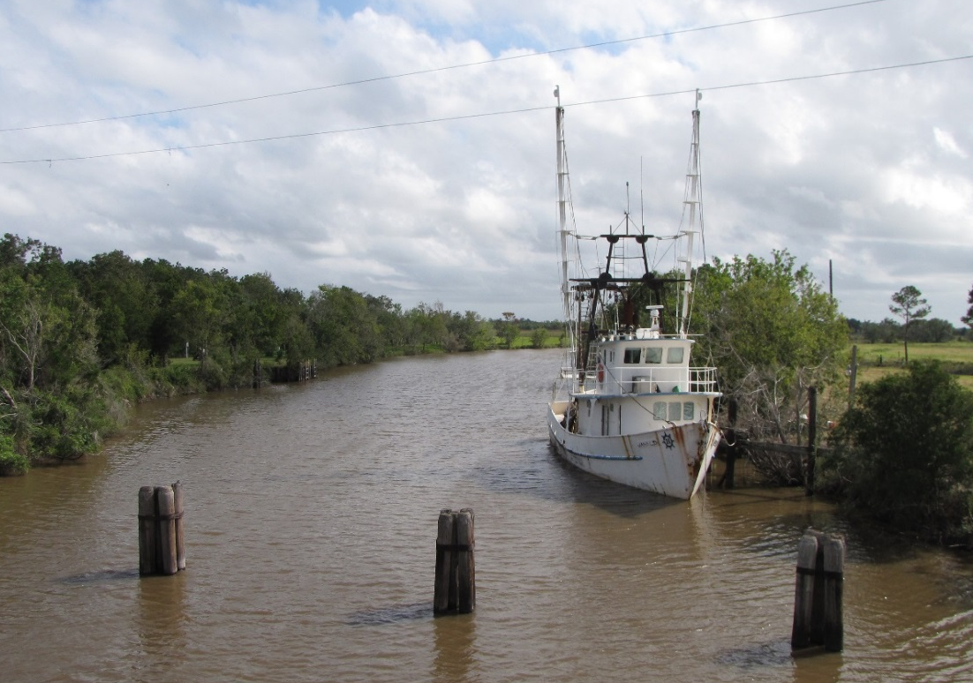
Figure ‎2-13 Commercial fishing vessel near Oak Island, TX
Along with commercial operations, recreational opportunities are abundant along the bayous. Job Beason Park and Fort Anahuac Park are equipped with full access to boat ramps, while Double Bayou Park has a canoe/kayak launch. Kayaking and sailing are popular forms of recreational boating. The three parks located within the watershed provide an ideal opportunity to serve as education centers, which could increase watershed awareness. The Double Bayou watershed is also a popular destination for wildlife viewing, birding and recreational fishing.
The Trinity Bay Conservation District (TBCD) actively manages the bayou’s riparian corridors through easements along the East and West Forks to improve drainage and reduce the impacts of flooding events. The application of herbicide to riparian vegetation and the dredging of the bayous are common practices.

Water Quality
The Double Bayou watershed consists of the TCEQ stream segments 2422A (Anahuac Ditch), 2422B (Double Bayou West Fork) and 2422D (Double Bayou East Fork). The TCEQ began monitoring the water quality of Double Bayou as part of the Clean Rivers Program (CRP) in 1969. The Texas Integrated Report, formerly known as the Texas Water Quality Inventory and 303(d) list, is a document containing a list of all impaired water bodies in the state of Texas. A waterbody can be listed for a water quality parameter of concern if the constituent does not meet the water quality standards determined by the TCEQ. The West Fork of Double Bayou was listed as impaired (not meeting its water quality standards) on the 2012 Texas Integrated Report for low dissolved oxygen (listed as impaired since 2004), high bacteria (listed as impaired since 2006), and listed for concern for chlorophyll-a. The East Fork of Double Bayou was listed for concern for low dissolved oxygen and high bacteria.
Low dissolved oxygen can be a concern for aquatic life, as they require a certain amount of dissolved oxygen to live and reproduce (See section 4.5 for more information). High bacteria can be a concern for people using a waterway for recreational use, because high bacteria can be an indicator of human disease causing pathogens in the water (Section 4.7).
For the PCBs and Dioxins impairment, most of the contamination is in the Houston Ship Channel sediments and it is transferred up the food chain to the fish. As a result of testing of fish tissue samples, and because fish are not confined to a given part of the bay, by 2010, all of Galveston Bay and its tidal tributaries, including the East and West forks of Double Bayou, were on the State’s impaired waters list – the 303(d) list – for PCBs and dioxin. A project is under way by TCEQ to figure out how to address the sediment contamination so that the fish concentrations will be reduced. No actions in the Double Bayou watershed will affect the fish tissue, but stakeholders can participate in the larger Galveston Bay project.

Wastewater Infrastructure

Permitted Wastewater Treatment Facilities
The Anahuac Wastewater Treatment Facility (WWTF) is the only municipal wastewater treatment facility that is in the Double Bayou watershed and that discharges directly into the bayou via the west bank of the Anahuac Ditch. The effluent from this facility is considered as a point source (pollutant attributable to one specific source) in the watershed. Located just south of Anahuac (29.7444, -94.6692), the facility is owned by the City of Anahuac and the Trinity Bay Conservation District and operated by the City of Anahuac.
The operators are required to report to the Clean Water Act’s National Pollutant Discharge Elimination System (NPDES) program. Currently, the wastewater treatment facility operates under the minor NPDES individual permit number TX0033944. The facility is permitted to discharge 0.6 million gallons per day of effluent.
The most recent compliance inspection was on 05/16/2013. The Anahuac WWTF has been out of compliance for 11 of 12 quarters from 10/01/2011 to 09/30/2014. However, the non-compliances have not resulted in significant violations. Chlorine as total residue fell below the monthly minimum on 4 occasions, while exceeding the monthly maximum once. Nitrogen, as total ammonia, has resulted in five violations with 2 daily maximum and 3 daily average exceedances. Exceedances of the pH minimum limit criterion have also resulted in non-compliance violations.
Typically, the WWTF’s E. coli effluent concentrations are well under the required 126 CFU/100 milliliter (mL) limit. However, during intense storm events, the wastewater pond is inundated with rain causing overflow into the Anahuac Ditch, which drains to the West Fork of Double Bayou. In addition, intense rainfall can cause problems with Infiltration and Inflow (I&I) to the City of Anahuac’s sewage collection system pipes, which also contributes to the overflow of the pond and to potential elevated levels of bacteria. (TBCD’s collection system to this plant is a force main sewer and thus is not vulnerable to I&I.) During these periods of intense rainfall, an increase of E. coli is evident in the receiving waters of the WWTF. Both the daily maximum and daily average E. coli criteria levels were exceeded on 10/31/2013 after receiving 2 inches of rain in a 5-day period.
A second facility, the Oak Island WWTF, owned and operated by the Trinity Bay Conservation District, is located near the community of Oak Island inside of the Double Bayou watershed (29.664389, -94.686861). However, the Oak Island WWTF’s effluent is discharged into Trinity Bay and is not considered to be a point source contribution to the watershed. As with the Anahuac WWTF, portions of the force main collection system for the Oak Island WWTF are in the watershed. While force main sewers do not have the opportunity for the I&I problems that gravity sewers have, leaky or failing pipes and joints in force main sewers are possible, and should be considered as a potential for nonpoint source of pollution.

On-Site Sewage Facilities
On-site sewage facilities (OSSF) are recognized as possible sources of bacteria and dissolved oxygen impairments in the Double Bayou watershed. There are over 450 septic systems in the Double Bayou watershed. This total number was determined from permitted OSSF data as well as local knowledge (stakeholder knowledge of homes not on public sewer systems). Septic systems in the Double Bayou Watershed range in age from new to well over thirty years old. Those OSSFs that range from twenty to over thirty years in age make up the majority of the septic systems in the Double Bayou Watershed.

References
Chilton, E. W. I., L. Robinson, et al. (2011). Texas State Comprehensive Management Plan for Aquatic Nuisance Speceis Texas Parks and Wildlife
Cowardin, L. M., V. Carter, et al. (1979). Classification of Wetlands and Deepwater Habitats of the United States, U.S Fish and Wildlife Service.
District, T. B. C. (2013). Trinity Bay Conservation District Hazard Mitigation Action Plan: FY 2013. Stowell, Texas.
Griffth, G., S. Bryce, et al. (2007). Ecoregions of Texas. Austin, Texas.
HARC. (2011). "Gulf Coast Portal; Coastal Waterbird Data From TPWD." Retrieved 2/15/2015, 2015, from http://gulfcoast.harc.edu/Biodiversity/Ecoregions/TexasLouisianaCoastalPlains/tabid/2256/Default.aspx.
Timmons, J. B., B. Alldredge, et al. (2012). Feral Hogs Negatively Affect Native Plant Communities, Texas A&M
Turco, D. W. B. a. M. J. (2006-07). Water-Quality, Stream-Habitat, and Biological Data for West Fork Double Bayou, Cotton Bayou and Hackberry Gully, Chambers County, Texas, 2006-07. U.S. Geological Survery Data Series 407.
Tyson, M. A. (2015). Personal Communication; Feral Hog (wild pig) Comments and Insight, Texas A&M AgriLife Research Extension.
USDA (2012). 2012 Census of Agriculture: County Profile for Chambers County, Texas, US Department of Agriculture
USDA (2012). Aquaculture sales: 2012 and 2007, US Department of Agriculture

