Public Participation

Project History and Development

Early Project Interest and Activity
The West Fork of Double Bayou was first included on the State’s list of impaired waters under section 303(d) for low dissolved oxygen in 2004, and for high levels of indicator bacteria in 2006. Dissolved oxygen (since 2010) and bacteria levels (since 2012) have indicated a cause for concern in the East Fork since. Trinity Bay is the receiving water for Double Bayou.
As part of its initiative to improve water quality in Galveston Bay, the Galveston Bay Estuary Program (GBEP) became interested in collecting additional data to better assess the water quality of both forks of Double Bayou, because the forks are tributaries of Galveston Bay. GBEP also wanted to explore whether a voluntary WPP could be beneficial for the Double Bayou watershed. A Double Bayou WPP could help prevent further degradation and restore watershed health through a voluntary, community driven process.
Public participation began in 2009, when GBEP facilitated funding for an initial study, from grants through the American Recovery and Reinvestment Act, the US EPA, state sources, and USGS. The funding provided resources for HARC to: (a) assemble and analyze existing water quality data for the watershed; (b) collect new water quality samples for both forks of Double Bayou, and analyze the data; and (c) share the information with key stakeholders, as well as the local general public.

The WPP Project
Since 2012, HARC has worked with the USGS and Shead Conservation Solutions – with funding from TSSWCB/EPA (federal Clean Water Act §319(h) grant) and GBEP/TCEQ – to develop a WPP for Double Bayou. The goal of the funded project was to develop a nine-element WPP for the Double Bayou Watershed, by:
- Establishing and providing direction for a stakeholder group that would serve as a decision-making body;
- Conducting routine and targeted water quality sampling and analysis;
- Identifying and analyzing spatial and temporal patterns in watershed data; and
- Increasing education among the targeted audience.

Partnership Development, Structure, and Meetings

Development of the Partnership
Local involvement is crucial for successful development and implementation of a WPP. Funding for the development of the Double Bayou WPP has opened the door for public participation. The initial stakeholder list from the previous study project was expanded to include anyone who could be identified as potentially interested in the Double Bayou WPP project – whether from an official perspective, as a vested interest, landowner, recreational user, technical resource, or from any other affected or interested perspective. The list was continuously updated throughout the WPP development, and used both to inform and to bring together stakeholders to work on the WPP.
From the onset, stakeholder interest in the Double Bayou WPP project was high. An invitation letter was sent to approximately 170 people, and 37 stakeholders attended the first kick-off meeting on May 21, 2013. UPDATE AT END: A total of XX individuals have participated in at least one meeting of the project.

Stakeholder Structure and Meetings
Due to the high level of interest, stakeholders have preferred for the Double Bayou Watershed Partnership to operate informally, as a “committee of the whole,” rather than have a restricted number of representatives serve as a Steering Committee to make decisions. Stakeholder meetings were typically held every 2-3 months, with workgroup meetings and/or workshops in between (Figure ‎3-1 Double Bayou partnership general stakeholder meeting). In total, thirteen general meetings, six sets of workgroup meetings, and five informational workshops were held during the WPP development process.
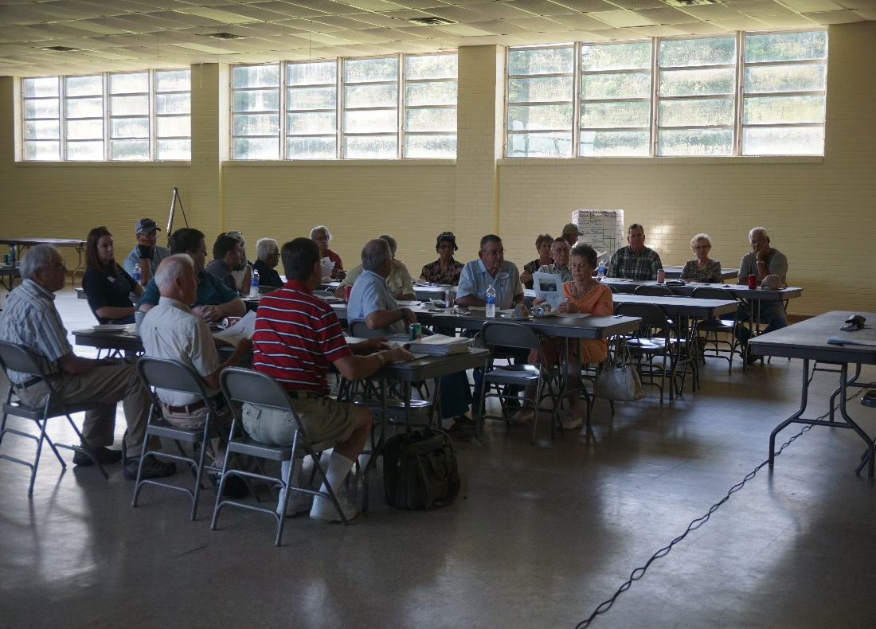
Figure ‎3-1 Double Bayou partnership general stakeholder meeting
Decisions from general stakeholder meetings were developed by informal consensus. Any objections or concerns were resolved before making decisions or moving on. Informal consensus was also used by workgroups and the task force to develop recommendations for passing on to the larger group of stakeholders for their consideration at the general meetings.
General stakeholder meetings were organized around sharing data and information that would be helpful for stakeholder decision-making and of interest to the general public, as well. Topics included concepts of in-stream water quality, results of monitoring, land use and land cover in the watershed, and modeling of potential bacteria sources, along with the results from workgroup discussions and recommendations. The final six months consisted of general monthly meetings focused on opportunities to review and provide input on chapters of the WPP document.

Workgroups
To develop more in-depth discussions of specific topics, stakeholders suggested forming workgroups in four categories: Agriculture/Wildlife/Feral Hogs, Recreation/Hunting, Wastewater/Septic, and Residential. The workgroups were based on groupings of a wide variety of potential pollutant sources identified during an early general meeting. Stakeholders chose the workgroup(s) in which they wished to participate, according to their interests and/or expertise. The Residential workgroup did not materialize as a specific workgroup; instead, the watershed coordinator conducted interviews with stakeholders on an individual basis in Anahuac to identify and discuss potential residential sources and solutions.
As the names imply, each workgroup focused on potential pollution sources related to those particular categories of topics. All the workgroups started with reviewing some of the basic concepts of watershed protection planning. The workgroups focused primarily on bacteria pollution, with related discussion on dissolved oxygen. The workgroups considered other water quality issues as well. After identifying specific potential pollutant sources, they considered the following: possible management measures, evaluation of source data, geographical allocation of sources, input on scenarios for SELECT modeling results (which included input on location and numbers of sources), and input for implementation schedules, milestones, and indicators. Each workgroup also developed a set of outreach and education programs that could address their particular pollution sources and solutions (see Chapter 7).
- The Agriculture/Wildlife/Feral Hogs Workgroup identified agricultural categories of potential bacteria pollution sources: (a) livestock (goats, cattle, horses) and (b) goats and horses in a confined setting. Combined with the work of a Geographic Task Force (see Chapter 2.4.2), they used extensive local knowledge to create a current (summer 2014) snapshot of land cover/land use in the watershed, particularly as it related to agricultural production. They also were able to define current estimated grazing densities of livestock based on the specific land cover.
The workgroup’s discussion of wildlife sources of bacteria ended up settling on categories for which population data could be obtained and which might potentially be addressed by management, such as deer. Some wildlife sources were considered background bacteria sources, as they occur somewhat naturally (i.e., were not specifically introduced by humans for agricultural production), and can be protected species. Other pollution sources/issues discussed were: feral hogs, game and livestock carcasses, fish kills, and collections of vegetation (on the water) (Figure ‎3-2 Agriculture/Wildlife/Feral Hogs Workgroup meeting).

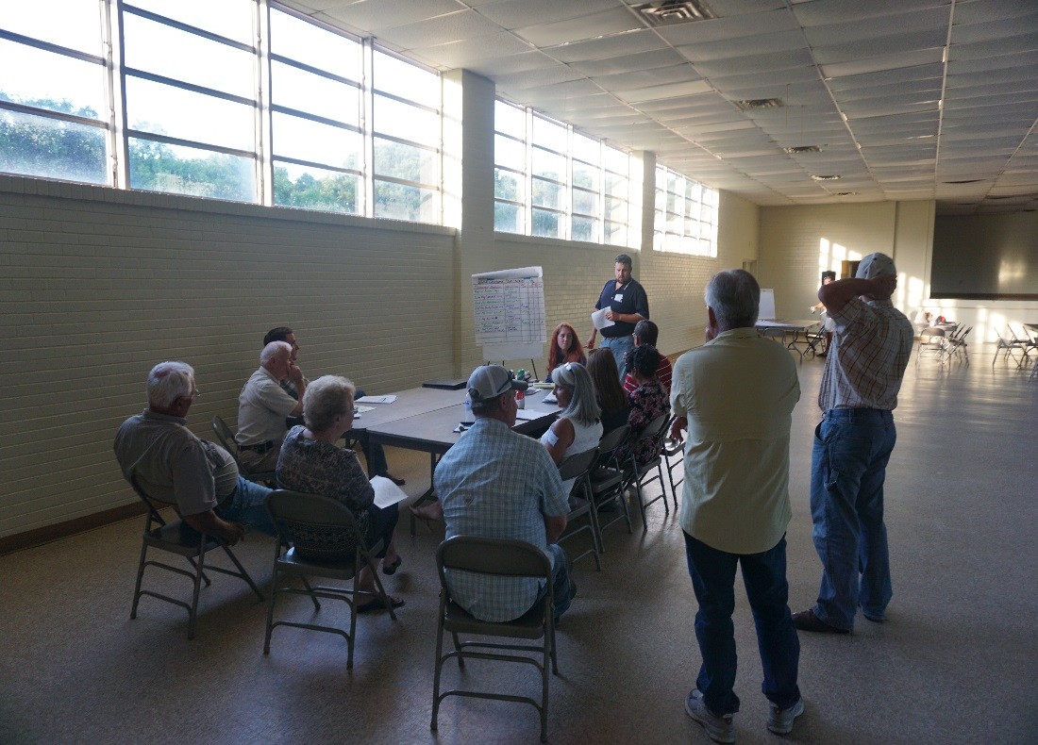
Figure ‎3-2 Agriculture/Wildlife/Feral Hogs Workgroup meeting
- The Recreation/Hunting Workgroup first identified the recreation/hunting activities common in the watershed, and then the bacteria or water pollution issues that could arise from those activities. Priority recreational/hunting bacteria sources that were considered throughout their process were: boater waste, concentration of scavengers, disposal of carcasses, and lack of public sanitation facilities.
Other water pollution issues for which this workgroup developed recommendations were: vehicle maintenance, litter, oil sheen from motorboats, lead from shooting ranges and fishing weights, invasive species, and sediment and loss of vegetation from erosion (ATVs and motorboats). This workgroup also considered feral hogs as a bacteria and as an erosion source.
- The Wastewater/Septic Systems Workgroup initially spent time learning and understanding the basic system of wastewater infrastructure in the watershed. For public infrastructure, that includes: which entities operate and maintain wastewater treatment facilities in the watershed; which of the wastewater treatment facilities discharge to Double Bayou or its tributaries; which entities collect wastewater in the watershed; and what kinds of collection systems in the watershed are potential sources (that is, gravity vs. force main systems).
For onsite sewage facilities (OSSFs), the key questions for evaluating potential sources were: what kinds of septic systems are in the watershed, where are they located and what age are they. Local expertise was critical in developing this data set. Straight pipe discharges were also discussed.

Workshops
In addition to the general and workgroup meetings, special workshops were held in the watershed to bring resources to local stakeholders – to assist in understanding the issues, and also to introduce practical solutions to watershed problems (Figure ‎3-3 Texas Riparian & Stream Ecosystem workshop). Many of the workshops also provided Continuing Education Credits (CEUs) needed by the stakeholders for various certifications. Workshops held for stakeholders (and others) during the Double Bayou WPP project were:
- Texas Watershed Steward Training: June 25th, 2013
- Feral Hog Management Workshop: June 27th, 2014
- Texas Riparian & Stream Ecosystem Workshop: September 24th, 2014
- Septic System Workshop: March 31st , 2015
- Texas Well Owner Network Workshop: May 28th , 2015

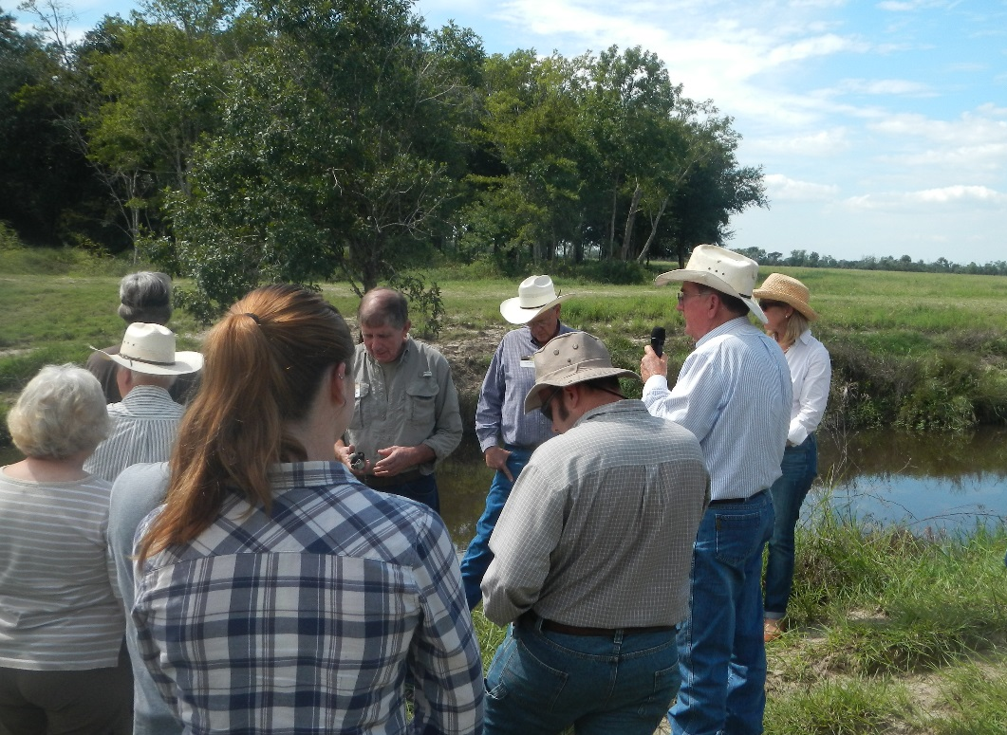
Figure ‎3-3 Texas Riparian & Stream Ecosystem workshop

Project Team
The Double Bayou Project Team was comprised of representatives from the funding agencies (TSSWCB, GBEP/TCEQ, and EPA) and from the participating organizations of HARC, Shead Conservation Solutions and USGS. The Project Team’s primary role was to provide the stakeholders with the data and information needed to develop the WPP. This included providing descriptions of watershed conditions, the new water quality data analysis and modeling results, and the suggestions for implementation. The Project Team met these primary objectives while meeting grant requirements and maintaining efficient and effective use of grant funds.
In addition to their specific roles of providing funding and of approving the direction and documentation for the project, the TSSWCB and GBEP representatives provided insights and experience from other WPP projects in the region and the state.
HARC served as the key developer of water quality data analysis and modeling, preparing graphs and exhibits of those data and modeling results, and preparing drafts of the WPP document chapters for stakeholder review and comment. Shead Conservation Solutions was responsible for the public participation component of the project, including maintaining communications with stakeholders through email and/or U.S. mail, preparing and distributing media items, providing notices of meetings and events, facilitating meetings, and preparing meeting documents. USGS was responsible for the collection and laboratory analysis of the additional water quality samples. In addition to a key representative, each entity on the Project Team also had other staff members or subcontractors who assisted with the project.

3.3 The Future and WPP Implementation
Watershed protection plans are guides for implementation of holistic water management solutions developed by local stakeholders. They are intended to be adaptive documents that will evolve as new data, partners, funding and stakeholders become available. This new information will be continually identified through tracking and monitoring of the implemented watershed protection plan. As with any watershed protection plan, implementation of the Double Bayou Watershed Protection Plan is entirely dependent on voluntary participation and on availability of funding. Continued stakeholder involvement in the implementation of the WPP is crucial to its success. (See Chapter 8 for the stakeholder-identified implementation process.)

