# Management Measures

## Management Measures Overview

This Management Measures chapter details the water quality management measures and associated best management practices (BMPs) suggested by the stakeholders to address the water quality issues identified through stakeholder interviews, workgroups and stakeholder meetings and through water quality monitoring. The chapter provides a suite of stakeholder recommended management measures that can be applied to the diverse categories of potential pollutant sources in the Double Bayou Watershed. The management measures discussed in this chapter employed in conjunction with the outreach and education programs in Chapter 8 will create a holistic watershed approach to improve the water quality of the Double Bayou Watershed. Management measures are proposed primarily to address bacteria concerns in the Double Bayou watershed, but most steps taken to reduce bacteria loads also will result in reductions from other types of pollution. All management measures are voluntary and contingent on available funding.

As discussed in Chapter 5, the Spatially Explicit Load Enrichment Calculation Tool (SELECT) was used in Double Bayou to estimate the distribution of potential pollutant sources across the watershed and degree(s) of contribution. Each potential pollutant source identified by the stakeholders was distributed based on the best available data and information regarding its presence in a given subwatershed. As a result of the SELECT analysis, areas and sources with the greatest potential for impacting water quality were identified and targeted for the management measures discussed below.

Stakeholders met during meetings and workgroups to discuss possible management measures to improve water quality in Double Bayou. Workgroups suggested possible management measures appropriate to their workgroup focus. The three main workgroups for Double Bayou were Agriculture/Wildlife/Feral hogs, Wastewater/Septic and Recreation/Hunting; see Chapter 3 for more information. Outreach and education measures were combined from the workgroups and are discussed together in Chapter 8.

Note that through the discussion there are several categories of management measures that are broad-based and will stretch across categories. Buffer zones, for example, will be discussed at length but may be applicable to multiple categories such as the reduction of nonpoint source runoff to support water quality objectives and to decrease access to the bayous for feral hog management.

## Double Bayou Management Measures

### Wastewater Management Overview

The WWTF wastewater management measures suggested by the Wastewater/Septic Workgroup can be further subdivided into those for two types of wastewater improvements – public wastewater systems and private system.

A public wastewater system is comprised of two components: the sanitary sewage collection system and the wastewater treatment facility (WWTF), which is the treatment plant itself. The collection system includes the sewer pipes, plus any lift (pump) stations out in the community that keep the wastewater flowing through the pipes, where gravity flow is not sufficient. Treatment of the wastewater occurs at the WWTF, in sequential treatment steps and including a lift station to pump the wastewater to the plant’s treatment units.

The City of Anahuac and the Trinity Bay Conservation District (TBCD) each provide and maintain infrastructure for public wastewater systems in the watershed. The clay pipe gravity sewer system that collects wastewater within Anahuac is maintained by the City, and that wastewater is treated at the Anahuac WWTF. It was noted by stakeholders that the clay pipe collection system is outdated and likely to cause I&I and should be a high priority for replacement. TBCD collects wastewater from outside the watershed through a force main sewer system and delivers it to the Anahuac WWTF for treatment. Treated wastewater from the Anahuac WWTF is discharged to the Anahuac Ditch, a tributary of the West Fork of Double Bayou.

TBCD also collects other wastewater from within the watershed, through a force main sewer system, but that wastewater goes to the Oak Island WWTF for treatment, and the treated wastewater is discharged to Trinity Bay, rather than to Double Bayou. The Oak Island collection system consist of modern PVC pipe and is not likely to be associated with the I&I issues that cause significant bacteria contributions to the bayous.

Private systems are generally septic systems of various sorts, also called onsite sewage facilities, or OSSFs. OSSFs provide minimal treatment in a tank, and then discharge the wastewater through or onto the ground for additional “natural” treatment. The two types of OSSFs used in the Double Bayou watershed are the conventional septic system and the aerobic septic system.

The Wastewater/Septic Workgroup consisted of personnel from the City of Anahuac, the Trinity Bay Conservation District, Chambers County, and other interested citizens who were knowledgeable about the various wastewater systems in the watershed. Together, they developed the proposed management measures that stakeholders then approved to be included in this WPP.

### Wastewater Collection System Infrastructure Improvements

A number of BMPs are applicable for facilitating infrastructure improvements to the Anahuac wastewater collection system. The City of Anahuac was suggested as the lead entity to implement these management measures, which would be addressed by the Watershed Coordinator working with the WWTF system operator.

The key to improving the sewer system will be determining what is needed and where it is needed. A leaky pipe system campaign was suggested as a first step to identify issues and sources of leaks in the City’s sanitary sewer system, including a sewer line test.

As part of this campaign, grants for homeowner implementation will be sought for low-flow devices. Stakeholders noted that use of low-flow devices would need to be coordinated with the sewer line size and slope; otherwise, there may not be enough flow to wash out solids, which then could cause problems when there is Infiltration and Inflow (I&I) that would wash the accumulated solids into the plant.

Another piece of the campaign would be the elimination of illicit connections. The Guidance Manual for Identifying and Eliminating Illicit Connections to Municipal Separate Storm Sewer Systems (MS4), prepared by the Galveston County Health District Pollution Control Division in cooperation with H-GAC, GBEP and TCEQ, could be used as a guidance manual to seek appropriate low budget solutions to potential high cost infrastructure issues.

Straight pipe discharges were also discussed as a possible source of bacteria contributions. For within the city, stakeholders suggested working with homeowners to route straight pipe discharges (identified through the above methods) into the main city sewer line.

Another resource is TCEQ’s Sanitary Sewer Overflow (SSO) initiative, which helps cities address problems with their collection systems that can lead to overflows of untreated sewage (https://www.tceq.texas.gov/field/ssoinitiative). A sanitary sewer overflow occurs when sewer lines are blocked, broken or aged to the point of allowing rain and groundwater to infiltrate into the pipes, which then breaches their designed capacity and causes the system to overflow. The City of Anahuac is already enrolled in the SSO program. A benefit of targeting I&I is that it may help to reduce the number and intensity of sanitary sewer overflows.

The three key recommended management measures are:

* ***Collection System Study****:* A smoke test and the use of video lines to identity priority areas to target for repair or replacement.
* ***Upgrade Collection System****:* Sanitary sewer line replacement and manhole cover replacement to prevent I&I from overwhelming the sanitary sewer system.
* ***Lift Station Upgrades****:* Utilizing bypass pumps that are less likely to fail in a peak flow situation than the current generators in use.

### Wastewater Management Measures for WWTF Operations

The stakeholders recommended the following as wastewater treatment facility management measures for plant operations:

* ***Staffing Capacity****:* Increasing the staffing capacity at the Anahuac WWTF will allow for conducting routine inspections of the plant, as well as of the sanitary sewer line system.
* ***Wire Thefts/Security****:* Wire thefts that have occurred in the past will be prevented with the use of surveillance cameras. Several thefts of wire from the plant have caused operational delays.
* ***Pump Repair and Replacement****:* High priority for the plant.

PLACEHOLDER: Plant Capacity KLKL

The Anahuac WWTF is large enough to treat the daily average flow as well as the 2 hour peak flow.

### Septic Systems Management Measures

The stakeholders recommended the following septic system management measures be performed under a septic system review and inspection initiative:

* ***Identify OSSFs in watershed; develop and maintain an OSSF database****:* This database was begun with the help of stakeholders and the geographic task force (see Chapter 2.4.2); the database includes location and general ages of septic systems in the watershed.
* ***Continued Enforcement of Septic System Complaints****:* Ensure current program response can expand with population growth.
* ***Increase Septic System Inspection Capacity****:* Include relief lines.

Additionally, the stakeholders suggested that connecting more homes that are currently on septic to a public wastewater system could reduce the amount of nonpoint source bacteria contributions from aging septic systems. The Trinity Bay Conservation District (TBCD) was identified as a possible lead entity for this initiative in the Double Bayou Watershed. The stakeholders identified some priority areas that would be optimal for new wastewater infrastructure (Table 6-1 Double Bayou Watershed septic systems).



Table 6-1 Double Bayou Watershed septic systems

To better understand and pinpoint the approiate subwatersheds to implement and seek funding for the maintenance and replacement of septic systems, the total number of septic systems per subwatershed was identified using ArcGIS. The number of failing systems per subwatershed was derived from the age set by the stakeholders. Because septic systems that are in close proximity (1,000 feet) to the bayous and the Anahuac Ditch pose a higher risk of increased bacteria contributions to the waterways they were also identified by applying a 1,000 foot buffer. (see Chapter 5, Section 5.7.2 for detailed discussion on age and placement of septic systems)

### Agricultural Nonpoint Source Management Measures

The Agriculture/Wildlife/Feral Hogs Workgroup recommended many agricultural best management practices (BMP) that could be used to address all potential agriculture related sources of bacteria. It was agreed that voluntary site specific management plans were the best method of implementing these on local farms and ranches. Water Quality Management Plans (WQMPs) are site-specific plans designed to reduce nonpoint source runoff from silvicultural and agricultural land uses. The plans are supported by the Trinity Bay Soil and Water Conservation District #434 (SWCD) and TSSWCB. To receive financial incentives from TSSWCB, the landowner must develop a WQMP with the SWCD that is customized to fit the needs of their operation. The Natural Resources Conservation Service (NRCS) also offers guidance and options for development and implementation of both individual practices and whole farm conservation plans. The landowners, in partnership with the SWCD and the WQMP Technician, would be lead entities for implementing the best management practices detailed in each WQMP. One benefit of the WQMPs is that an individual BMP can help to reduce contributions from several different sources. Each WQMP needs to be developed and certified in order to receive funding to implement the BMPs describe in the WQMP.

The stakeholders suggested that the creation of a WQMP Technician position could support plan development in the watershed. This position would be dedicated to assisting landowners in the creation and implementation of the WQMPs. Because a number of WQMPs are already certified in the watershed, the WQMP Technician will not only focus on enrolling more landowners, but will place an emphasis on WQMP plan updates, as well. The technician would be involved in writing, planning and promotion of the WQMPs. In addition, the technician would help secure potential funding for current and new WQMPs. Working together, the WQMP Technician and Watershed Coordinator could organize and host workshops, and coordinate with Texas A&M AgriLife Extension on any relevant programs. The WQMP Technician will likely be stationed in Anahuac, and employed by the Trinity Bay SWCD.

### Livestock Operations

The average farm size in Chambers County was determined to be 346 acres, according to the 2012 USDA National Agricultural Statistics Service (NASS) census of agriculture. An average animal unit of 38 was calculated per farm in Chambers County; based on the number of farming operations and cumulative number of cattle, calves and horses per each operation in the county. The number of total animal units (cattle and horses) in each subwatershed of Double Bayou was generated using the SELECT model (Figure 6-1 Double Bayou subwatersheds). The total number of animal units per subwatershed was then divided by the number of animal units per farm in Chambers County (38 AU). From this calculation the number of farms per subwatershed was derived (Table 6‑1 Recommended number of WQMPs). (Note that in the following sections, the “high” scenarios (see Chapter 5 for the SELECT scenarios discussion) were used for analyzing load reductions so that the recommended management measures would be able to minimize loads for the highest scenarios.)

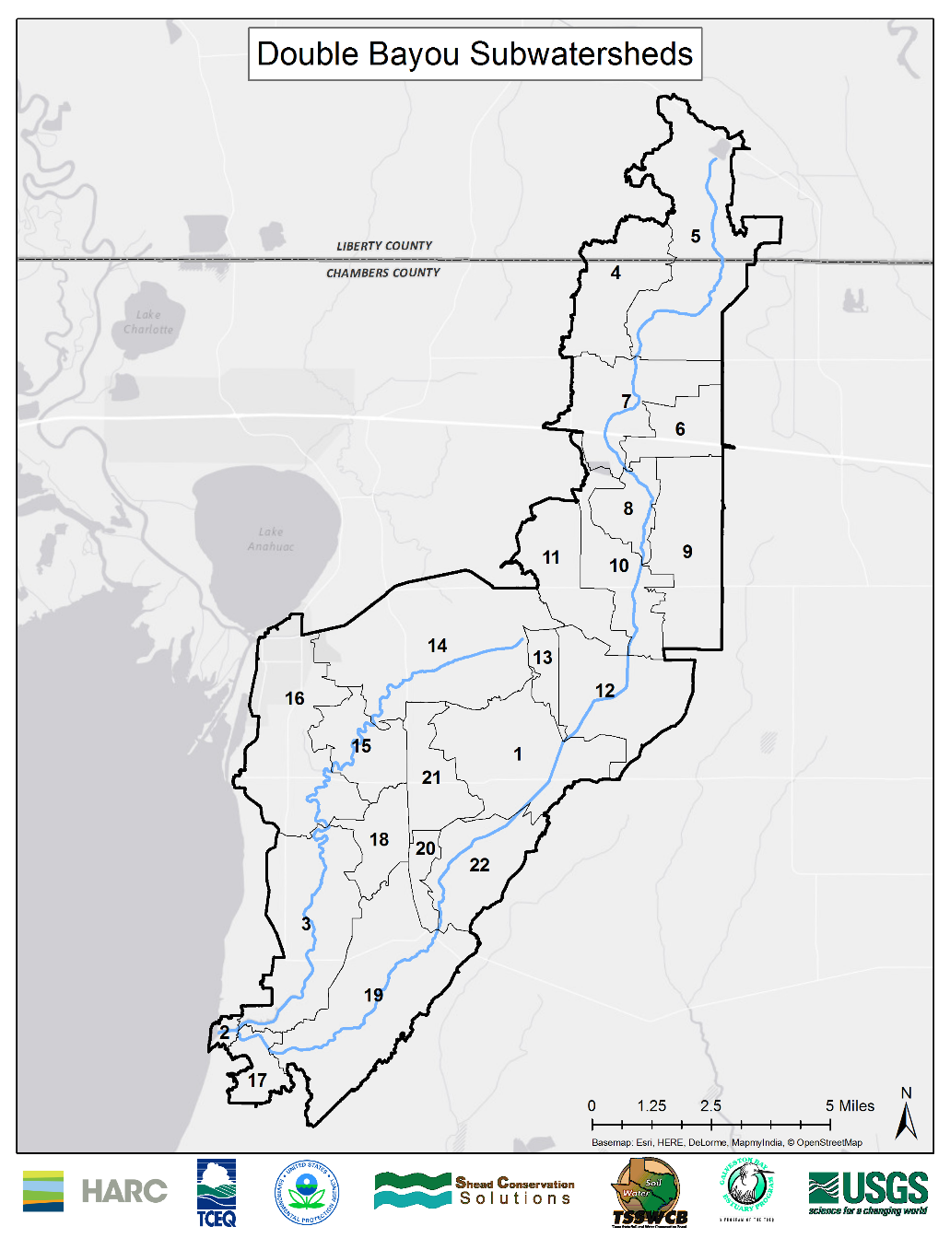

Figure 6-1 Double Bayou subwatersheds

PLACEHOLDER: UPCOMING, to be calculated - The percentage of bacteria reduction (%) was then applied to the total number of livestock operations in each subwatershed to determine the number of recommended WQMPs needed in each subwatershed (Table 6-2 Recommended number of WQMPs). A total of XX WQMPs are recommend, ranging from XX to XX depending on the subwatershed. To find the total number of animal units per subwatershed, we can work backwards from the output of the select model and divide against the fecal loading rate and *E.coli* conversion factor. This is done for each livestock input (in our case cattle, and horses (with their respective fecal loading rates) to get the number of animals per subwatershed. This number is then converted to AU (1,000 pounds live weight) and summed to get AU per subwatershed.

|  |  |  |  |
| --- | --- | --- | --- |
| **Subwatershed** | **Animal Units** | **Number of Farms per Subwatershed** | **Recommended Number of WQMPs** |
| 1 | 320 | 8 | TBD |
| 2 | 4 | 0 | TBD |
| 3 | 243 | 6 | TBD |
| 4 | 353 | 9 | TBD |
| 5 | 457 | 12 | TBD |
| 6 | 39 | 1 | TBD |
| 7 | 175 | 5 | TBD |
| 8 | 105 | 3 | TBD |
| 9 | 299 | 8 | TBD |
| 10 | 237 | 6 | TBD |
| 11 | 149 | 4 | TBD |
| 12 | 226 | 6 | TBD |
| 13 | 45 | 1 | TBD |
| 14 | 712 | 19 | TBD |
| 15 | 174 | 5 | TBD |
| 16 | 332 | 9 | TBD |
| 17 | 43 | 1 | TBD |
| 18 | 110 | 3 | TBD |
| 19 | 356 | 9 | TBD |
| 20 | 4 | 0 | TBD |
| 21 | 115 | 3 | TBD |
| 22 | 134 | 4 | TBD |
| **Total** | **4631** | **122** | **0** |

Table 6-2 Recommended number of WQMPs

SELECT identified cattle from livestock operations as a potential principal contributor to bacteria in the Double Bayou Watershed (Figure 6-2 Livestock along West Fork Double Bayou). Horses were also identified by SELECT as having a moderate potential. Emphasis will be placed on the management measures which reduce bacteria runoff into the bayous. BMPs that are multiuse management measures will be given priority and should be included in the WQMPs as much as possible.

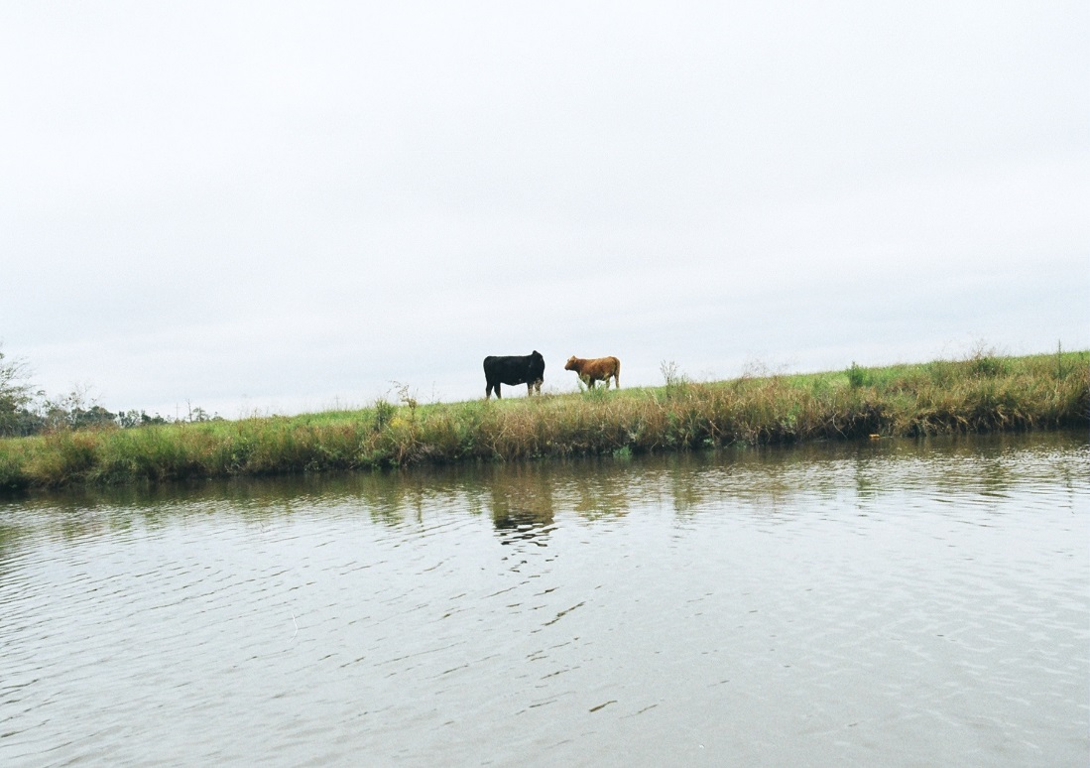

Figure 6- Livestock along West Fork Double Bayou

The stakeholders suggested that the following BMPs would be some examples that would address nonpoint source runoff from agriculture and livestock in the Double Bayou watershed (Technical reference for agricultural BMPs (Peterson, Jordan et al. 2012)):

* ***Prescribed Grazing***: The controlled harvest of vegetation by grazing animals to facilitate stable plant communities that can then improve surface and subsurface water quality.
* ***Alternative Water Sources***: Can be a permanent or semi-permanent off-stream structure such as, a trough, pond or similar vessel that allows livestock to drink ample supplies of fresh water away from the bayou. At this distance they are less likely to distribute fecal waste directly into the receiving waters. The alternative water sources often provide a shade structure as an additional incentive for use by livestock.
* ***Stream Crossings***: Provide a safe crossing for livestock, grazing animals and people to cross the bayou. Stream crossings are more stable than the bayous bank which, can be eroded by livestock causing sedimentation of the waterways. The crossings give livestock an opportunity to drink while reducing the overall instream loafing time. Stream crossings can also prevent injury to livestock that are forced to cross steep banks when seeking a water source or trying to cross the bayou.
* ***Grade Stabilization Structures***: A structure used to control the grade and head cutting in natural or artificial channels. To stabilize the grade and control erosion in natural or artificial channels, to prevent the formation or advance of gullies, and to enhance environmental quality and reduce pollution hazards.
* ***Cross Fencing***: Used to promote rotational grazing, and makes the task of maintaining healthy grass heights with prescribed grazing easier. Promotes infiltration and slows down runoff.
* ***Shade Structures***: Can be used in conjunction with an alternative water source or as a lone standing structure that will provide shade to grazing animals. Shade structures are most effective when placed away from the bayou and offer shade to entice livestock away from the cool shaded riparian corridor along the bayou.
* ***Riparian Herbaceous Buffers***: Improve water quality in the bayou by filtering surface runoff to reduce the sediment load and allow natural absorption process time to remove the nutrient load from runoff. They can also inhibit fecal indicator bacteria from reaching the waterway. Could also provide more shading over the bayou to help prevent fish kills.
* ***Buffer Zones***: Buffers between flooded fields and bayous, i.e. vegetative filter strips and streamside buffers to reduce nutrient and bacteria loading from wildlife and livestock. In forested areas, this would be 50 feet on either side of the channel to be considered a buffer, which is a common minimum for riparian buffer zones.
* ***Nutrient Management***: Can reduce bacteria and nutrient loading to the bayou by providing a plan to apply the correct amount of fertilizers and manure at the optimal times. This BMP is best used in conjunction with the soil testing campaign described in Section 8.2.5.

### Wildlife and Non-Domestic Plant/Animal Management Measures

Native wildlife such as deer, raccoons, opossums, and bird species can be contributing sources to bacterial pollutants, this is considered background nonpoint source pollution for Double Bayou. TPWD manages native wildlife in Texas; active management of native wildlife for water quality purposes is generally not promoted in the State of Texas and will not be included in the Double Bayou Watershed Protection Plan.

Deer ranked last among all scenarios run in SELECT for their potential to contribute to the nonpoint source pollution of the waterways. The small amount of bacteria contributions from deer and the fact that they are native to the bayous was enough for the stakeholders to suggest that they be counted as part of the background bacteria concentrations along with other wildlife such as raccoons, birds and small mammals. The stakeholders remarked that some of the WQMP practices such as vegetative buffers (i.e. filter strips and streamside buffers areas) between flooded fields and the bayou could help to reduce the amount of bacteria from native wildlife populations although the BMPs weren’t intended for that purpose.

GBEP has educational material on invasive species, which could be a potential resource for the Double Bayou Partnership. The manual removal of aquatic and terrestrial invasive species during physical removal days, similar to a trash bash event, could be coupled with the riparian area outreach and education measures (see Chapter 8 for discussions on riparian area outreach and education). Masses of non-native vegetation that has collected in the bayous could also be removed during this event.

PLACEDHOLDER, UPCOMING – to be calculated: The SELECT results highlighted feral hogs as the second highest potential source of bacteria contributions to the bayous. The stakeholders agreed that feral hogs and their bacteria contributions should be given a high priority. To determine the estimated number of feral hogs that should be removed, the number of hogs for each subwatershed was multiplied by the bacteria load reduction XX% (Table 6-3 Recommended number of feral hogs to be removed by subwatershed).

|  |  |  |
| --- | --- | --- |
| **Subwatershed** | **Total Hogs** | **Hogs to be removed** |
| 1 | 107 | TBD |
| 2 | 4 | TBD |
| 3 | 105 | TBD |
| 4 | 63 | TBD |
| 5 | 157 | TBD |
| 6 | 38 | TBD |
| 7 | 77 | TBD |
| 8 | 32 | TBD |
| 9 | 88 | TBD |
| 10 | 56 | TBD |
| 11 | 60 | TBD |
| 12 | 82 | TBD |
| 13 | 16 | TBD |
| 14 | 164 | TBD |
| 15 | 47 | TBD |
| 16 | 110 | TBD |
| 17 | 21 | TBD |
| 18 | 33 | TBD |
| 19 | 135 | TBD |
| 20 | 16 | TBD |
| 21 | 45 | TBD |
| 22 | 63 | TBD |
| **Total** | **1519** |  |

Table 6-3 Recommended number of feral hogs to be removed by subwatershed

SELECT identified the bacteria contribution from the feral hog population in the Double Bayou Watershed as large enough to warrant the creation of a Feral Hog Management Plan. The plan would be comprised of the feral hog management measures discussed in this section. Concern was expressed by the stakeholders that an effective feral hog management system in the Double Bayou Watershed may simply drive the feral hogs across neighboring borders where management measures are not in place or may be lax. Due to the transboundary management requirements of feral hogs, the stakeholders explicitly suggested that the Double Bayou Watershed Partnership form relationships with neighboring watersheds and counties to eradicate the feral hogs from the region. Furthermore, the stakeholders also suggested holding a workshop to discuss the potential for a statewide feral hog management program. However, until a statewide program can be discussed, the Agriculture/Wildlife/Feral Hog workgroup suggested the following feral hog management measures for the Double Bayou Watershed:

* ***Feral Hog Specialist***: The existing Texas AgriLife Extension Feral Hog Specialists for South Texas will be available to work in the Double Bayou watershed. The specialist will be able to lend technical assistance and insight for trapping and managing the feral hog population.
* ***Feral Hog Management***: Will include the creation of a County feral hog position that will assist stakeholders and allow them to borrow trapping equipment and tools. Management measure may include: Trapping, aerial shooting, exclusionary fencing and increased hunting and removal.

The stakeholders also expressed a desire for the County to implement a program that will issue bounties for feral hogs. They suggested that the bounty would provide an incentive to increase the hunting of feral hogs.

### Recreation Management Measures

The Recreation/Hunting Workgroup met to discuss management measures to reduce the amount of nonpoint source bacteria from recreational activities in the Double Bayou Watershed. To address the boater waste issue, the stakeholders suggested the creation of a pump out station at Job Beason Park. The installation and maintenance of the pump out station could be handled by the County and the Galveston Bay Foundation. The goal would be to promote the use of the pump out station that will be in a readily accessible area. The more that recreational boaters use the pump out station, the less boater waste will be discharged into the bayous and adjacent Trinity Bay.

Compared to the abundant recreational activities in the watershed, there are relatively few sanitation facilities for stakeholders and recreationalist. The potential creation of other restrooms was noted as a possible management measure by the stakeholders although it was recognized that other management measures are higher priority. ChambersWild is one organization that may be able to facilitate this management measure. Another recreational issue in the watershed is the sedimentation of the bayous from erosion caused by recreational ATVs and motorboats in riparian areas. The stakeholders stated that the damaged caused by these recreational activities and subsequent loss of vegetation should be addressed. A larger issue of concern to stakeholders is oil sheen from motorboats; an idea is the creation of an incentive program to people who either replace their older boat engines or keep them in proper working order. The stakeholders expressed interest in developing and facilitating this initiative.

References

Peterson, J., E. Jordan, et al. (2012). Lone Star Healthy Streams Dairy Cattle Manual, Texas A&M AgriLife Extension.