Outreach and Education Management Measures

Outreach and Education Approach

Role of Outreach and Education
The WPP and its implementation are stakeholder driven processes. Therefore, to include and inform as many stakeholders as possible, this chapter details outreach and education management measures, suggested and agreed upon by stakeholders, that are aimed for successful communication and implementation of this WPP’s management measures. It is crucial to inform stakeholders of how different choices can impact water quality. Thus, outreach and education management measures will be vital to the success of the implementation of the Double Bayou WPP. These measures will provide the awareness upon which the success of all other management measures will be built.

Initial Outreach and Education Activities
Ongoing throughout the development of the Double Bayou WPP, outreach and education activities have included: general meeting presentations, workshops, project website, fact sheets and brochures, newsletters, and outreach to public officials.
Informational presentations by agency partners were incorporated into general stakeholder meetings on the topics of: Lone Star Health Streams, PCBs and Dioxins in the Galveston Bay System, Onsite Wastewater Treatment Systems, TCEQ Assistance for Local Governments and Small Businesses, and the Cease the Grease campaign.
Also in cooperation with Texas A&M AgriLife Extension Service (Extension), public workshops were organized during the WPP development process to bring more extensive training to the stakeholders and general public on watershed-related topics (see Section 7.2.2. for a detailed discussion of these programs)(PLACEHOLDER UPDATE # of participants):
- Texas Watershed Steward Training held on June 25th, 2013 (XX participants)
  - A statewide comprehensive program provided by the TSSWCB and Extension to educate local stakeholders on watersheds and water issues. The program provides the knowledge to allow community members to take on leadership roles to proactively improve and protect water resources in their watershed.

- Double Bayou Watershed/Chambers County Feral Hog Management Workshop held on June 27th, 2014 (XX participants)
  - This workshop is sponsored by Extension to provide information on feral hog biology, laws and regulations, interactions with native wildlife and management measures, along with up-to-date research efforts regarding feral hog disease concerns, interactions with native wildlife and management measures.

- Double Bayou Watershed Texas Riparian & Stream Ecosystem Workshop held on September 24th, 2014 (xx participants)
  - This workshop provided Double Bayou stakeholders with classroom presentations and field demonstrations to highlight the hydrology, natural and healthy riparian functions and possible causes of riparian degradation. The program is supported by the TSSWCB, Extension, NRCS, USGS and the Texas A&M Forest Service.

- Septic System Maintenance Workshop for Homeowners held on March 31st, 2015 (XX participants)
  - This informational program is sponsored by Extension to raise awareness of how everyday activities can affect septic system operation. Homeowners that have anaerobic or aerobic septic systems learn about how septic systems function, care and feeding of the system and proper maintenance procedures.

- Texas Well Owner Network Workshop held on May 28th, 2015 (XX participants)
  - This workshop is sponsored by Extension and the TSSWCB to provide private water well owners with affordable water quality testing along with an educational program centered on groundwater resources, well maintenance and well water treatment.
The Double Bayou Watershed Partnership website (http://www.doublebayou.org/) was developed to provide a vehicle for updating stakeholders on the WPP process and to organize all available content such as meeting announcements, notes and presentations (Figure 7-1).

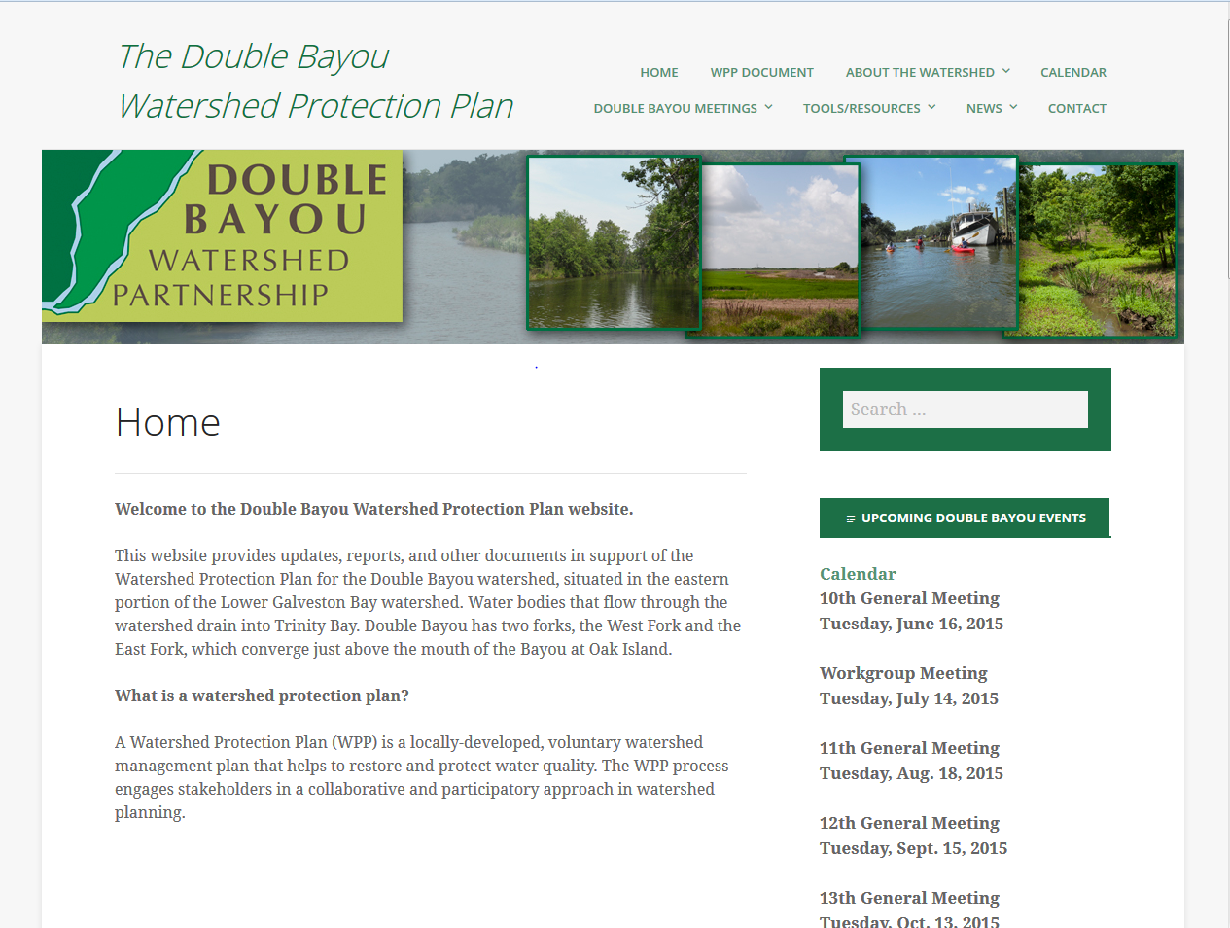
The Double Bayou Watershed Fact Sheet (Figure 7-2) and the Double Bayou Watershed Partnership Brochure (Figure 7-3 Double Bayou Watershed Partnership brochure (front and back)) were created for the Double Bayou Watershed Partnership to educate stakeholders about the Double Bayou watershed, the watershed protection planning process and water quality issues in the watershed. They were also used as marketing and outreach materials to inform stakeholders and the general public of the Double Bayou watershed protection plan and gain more local support and input.
Figure 7-1 Double Bayou Watershed Partnership website
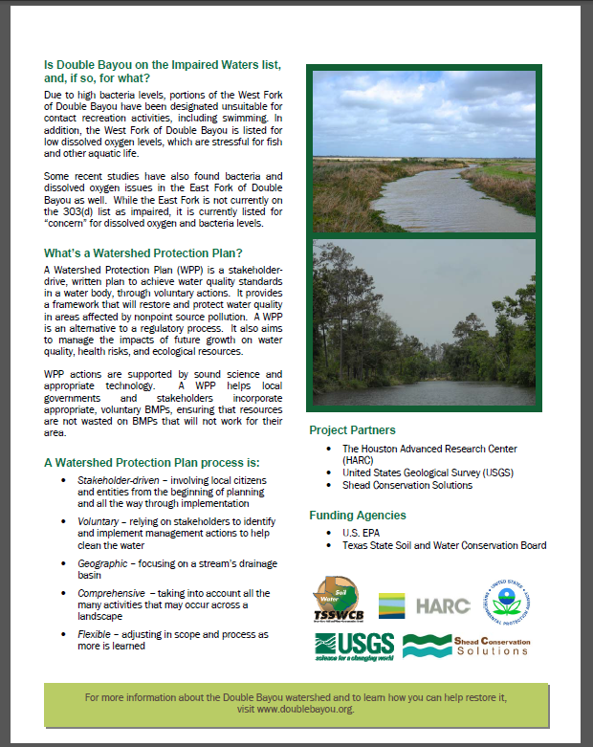
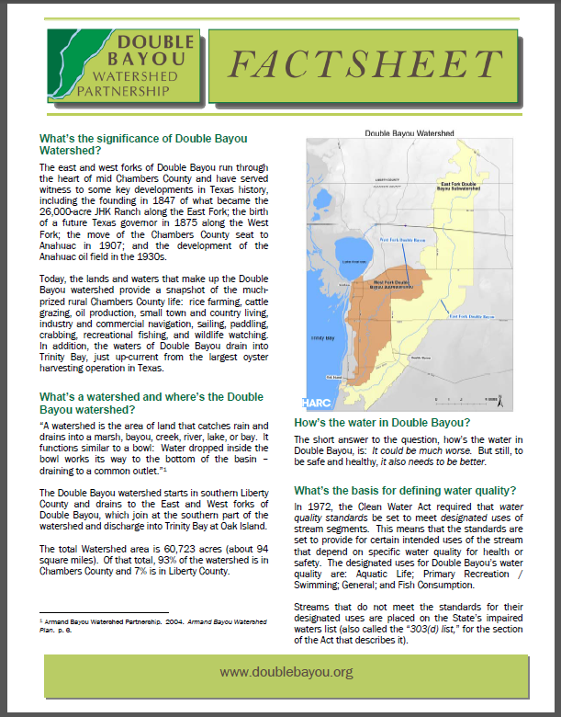
Figure 7-2 Double Bayou Watershed Partnership factsheet

During the watershed protection planning process, four informational newsletters have been issued by the Double Bayou Partnership. The newsletters serve as outreach and education materials and to keep stakeholders updated. The June 2014 newsletter introduced the WPP concept, described why the plan is needed in the Double Bayou watershed and offered a local stakeholder’s perspective. The December 2014 newsletter included advanced discussions on what the Double Bayou WPP process is, the importance of the bayous riparian areas and biological drivers of feral hog behavior. The May 2015 newsletter highlighted award-winning stakeholders, a new Double Bayou Watershed Partnership partner, an update on the WPP project, another local stakeholder perspective and additional resources for stakeholders. PLACEHOLDER: UPDATE with October 2015 newsletter info.
Press releases were developed and distributed throughout the Watershed Protection Plan development process to inform stakeholders of upcoming meetings, or to give details of workshops or WPP events.

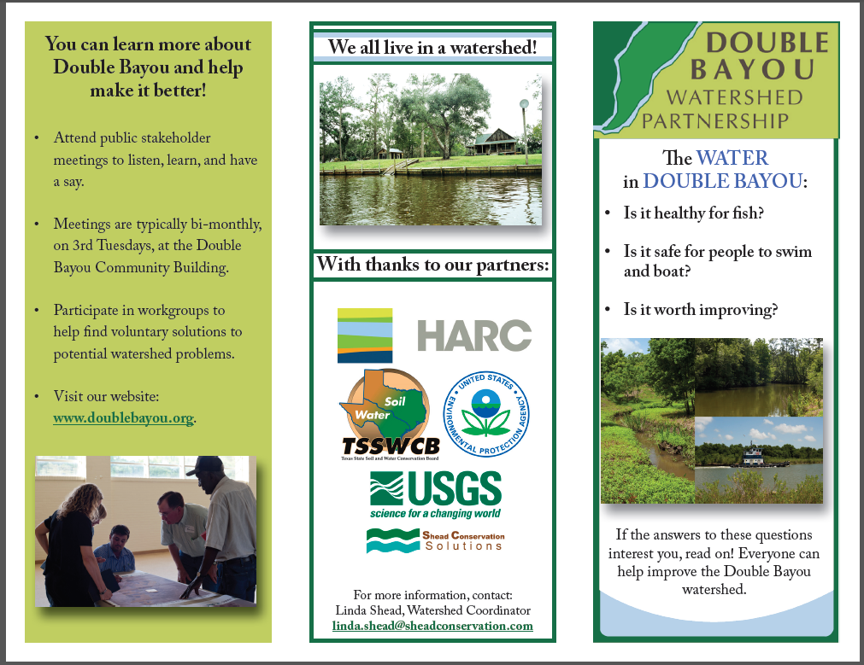
Figure 7-3 Double Bayou Watershed Partnership brochure (front and back)
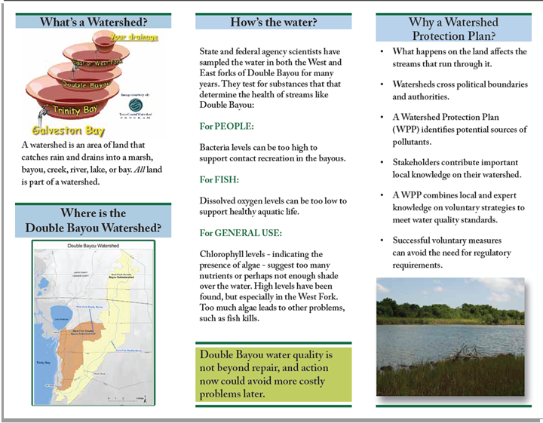

Implementation Phase Overview
To facilitate the stakeholder recommended outreach and education management measures, a Watershed Coordinator position is needed. It will be the primary duty of the Watershed Coordinator position to oversee the implementation of the outreach and education measures detailed in this chapter. The person in the watershed coordination position will routinely interact with stakeholders, local city councils, county commissioner courts, Extension, GBF, TCEQ, TSSWCB and other watershed interest groups to keep them informed and involved in implementation activities. The Watershed Coordinator also will work to secure external funding to facilitate stakeholder recommended implementation activities outlined in the Double Bayou Watershed Protection Plan. The stakeholders also expressed that having educational materials printed in both English and Spanish would maximize the number of residents who would be able to benefit.
The stakeholders also recommended that the Watershed Coordinator develop or utilize current age-encompassing materials to target different school grades. The stakeholders noted this will be an effective form of outreach, because the youth will then share the materials and knowledge with their parents. One possible school-age group to target is the Roots and Shoots Club at Anahuac High School, which is oriented towards environmental activities.
Also, each of the methods described in Section 7.1.2 will continue during the implementation of this plan: general meeting presentations, workshops, fact sheets and brochures, project website, newsletters, and outreach to elected officials.
In summary, based on stakeholder recommendations, Outreach and Education during implementation of the Double Bayou WPP will be based on three key strategies:
- Create a watershed coordinator position to oversee and integrate the outreach and education measures,
- Partner with other entities on both securing funding and on-the-ground implementation, and
- Utilize existing materials and programs wherever applicable and possible, developing and/or adapting them to be specific for the Double Bayou watershed, as appropriate.

Stakeholder Recommended Outreach and Education Management Measures

Stakeholder Management Measures Overview
Stakeholders met during general public meetings and workgroup meetings (the three main workgroups for Double Bayou were Agriculture/Wildlife/Feral hogs, Wastewater/Septic and Recreation/Hunting) to discuss possible management measures to improve water quality in Double Bayou. Workgroups suggested possible management measures appropriate to their workgroup focus, and all workgroups had a significant number of Outreach and Education Management Measures suggested as part of their overall management measures. The lists of workgroup recommendations were then discussed and accepted, with some modifications, at a general stakeholder meeting.
Many of the measures often overlapped among the group recommendations. As a result, they were merged into one collective stakeholder-recommended Outreach and Education Management Measures list and are discussed in the following sections.

Broad-Based Programs
Workshop Programs such as the ones discussed in Section 7.1.2 will continue to be offered to the stakeholders of Double Bayou during WPP implementation (Figure 7-4). These workshops serve to benefit the watershed as whole and encompass many nonpoint source pollution issues that are present in the watershed.
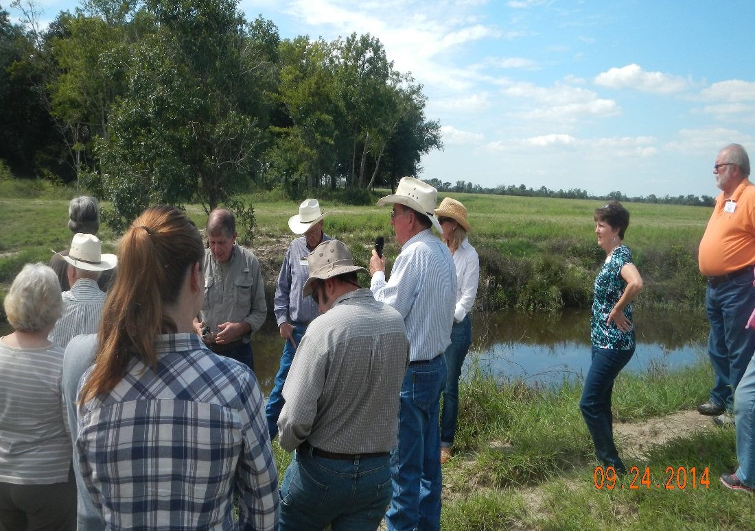
Figure 7-4 Double Bayou Texas Riparian & Stream Ecosystem Workshop
The Texas Watershed Steward program is a statewide water resource training program sponsored by Extension and the TSSWCB to inform stakeholders of watershed and water quality issues. Its purpose is to: “promote healthy watersheds, increase understanding of the potential causes of water resource degradation, and give people the knowledge and tools they need to prevent and/or resolve water quality problems.” It specifically targets nonpoint sources of pollution and provides the knowledge to enable implementation of BMPs that will preserve, protect and enhance the Double Bayou watershed.
The Texas Riparian & Stream Ecosystem Workshop is a collaboration of the Texas Water Resources Institute and numerous other state, local, and federal resource agencies. This day-long workshop is part of a program to “promote healthy watersheds and improve water quality through riparian and stream ecosystem education.” It increases citizen awareness and understanding of the nature, function, and benefits of riparian zones, and of how to manage them to minimize nonpoint source pollution.
The Feral Hog Management Workshop sponsored by Extension provides information on hog biology and population dynamics, effects on water quality, regulations, and feral hog controls/management through methods such as trapping. Feral hogs are a state wide problem that have water quality impacts in numerous watersheds.
The Texas Well Owner Network Workshop sponsored by Extension and the TSSWCB will continue to be offered. This is a one-day workshop for private well owners and provides resources on well maintenance, water quality and water treatment, water supply, and groundwater resources. As well, the workshop provides well owners the opportunity for affordable well water screening; well owners can bring in samples of their well water to be screened for common contaminants including fecal coliform bacteria, nitrates, arsenic and high salinity
The NEMO (nonpoint source education for municipal officials) program sponsored by Extension and Texas Sea Grant, is another broad-based outreach and education initiative that provides factsheet resources for municipal officials about best management practices to alleviate the impacts to water quality caused by stormwater and nonpoint source runoff.
The Galveston Bay Foundation has implemented an interactive web and mobile application, the Galveston Bay Action Network (GBAN), which is funded through the Texas Coastal Management Program by NOAA and U.S. EPA, and will be promoted during implementation. GBAN is an application for submitting and viewing water related pollution reports across the four counties around Galveston Bay, which includes Chambers County. GBAN pollution reports are sent directly to the appropriate authorities, making it easy for stakeholders to report concerns. These pollution events can range from boat sewage to trash and debris.
Broad-based outreach and education activities that are less structured around a specific program would include providing displays of educational materials on watershed topics at local events, which could be rotated depending on the aspect of the partnership that needs greater awareness. Watershed roadway signage will be utilized to increase people's awareness that what they do on the land can affect the water of the bayou and to promote general watershed awareness. The stakeholders suggested that a test-your-watershed-knowledge game be developed for distribution through social media and the ChambersWild website. A continuous advertisement in the Anahuac newspaper can help to promote awareness of the Double Bayou Watershed Partnership and upcoming outreach and education workshops as well as targeted campaign information, such as illegal dumping.

Wastewater Programs
A dual approach will be taken to address the stakeholder’s wastewater concerns. First, the Watershed Coordinator will lead watershed-wide campaigns and build partnerships with current wastewater programs that are in place to educate stakeholders on how homeowners affect their wastewater infrastructure at an individual level. This would include information regarding homeowner responsibilities for maintenance of their lateral lines (the sewer pipe from the home to the public sewage system). This will also serve as a preventative measure to increase the effective operation of the Anahuac WWTF and individual septic systems.
Specifically, the Watershed Coordinator will work with the Galveston Bay Foundation to bring their Cease the Grease program (http://galvbay.org/ceasethegrease/) to local watershed residents. This program details the problems that fats, oils and grease create for wastewater infrastructure and offers alternatives to dumping fats, oils and grease down the drain.
To aid in this outreach measure, the stakeholders agreed that the No Wipes in the Pipes/ Patty Potty Patrol Campaign (http://www.pattypotty.com/) maintained by the San Jacinto River Authority would also be a reasonable outreach and education tool to implement watershed-wide, along with the Cease the Grease Campaign.
The second approach will be to include options for financing or organizing classes and training opportunities for wastewater professionals. The Texas A&M Engineering Extension Service (TEEX) courses were suggested by stakeholders for the Anahuac WWTF wastewater professionals who have not already taken the courses. TEEX water and wastewater bacteria troubleshooting and operations training classes will be offered for WWTF operators. The TEEX program offers all training requirements for state licensing of water and wastewater professionals. The training opportunities offered by the Trinity Valley District of the Texas Water Utilities Association were also suggested for local wastewater professionals.

Septic Systems Programs
The stakeholders suggested two methods of effective outreach and education through utility connections. One would be marketing of new-homeowner education at the time of connections, and the other would be to include educational information with utility bills, such as an introduction to OSSF (including a homeowner’s septic system responsibilities). Notifications of educational programs (including an aerobic system workshop) for existing homeowners could also be offered through this mechanism.
Different types of outreach programs, such as workshops, would help in informing homeowners about improved septic system maintenance, and about alternatives for those who may have a relief line from their septic tank. Materials on the proper use of gray water will be offered to inform homeowners about the need for a filter on the gray water line. Another suggested outreach program was to develop a reporting process for boaters to report straight pipe discharges in order to target education (Figure 7-5).
The Septic System Maintenance Workshop will continue to be offered. This workshop is sponsored by Extension and covers the septic system treatment processes, health and safety considerations for homeowners as well as how to inspect and maintain the system. This workshop also provides answers to the most frequently asked septic system questions, including the best schedule for pumpout of a tank and what can or cannot go down the drain.

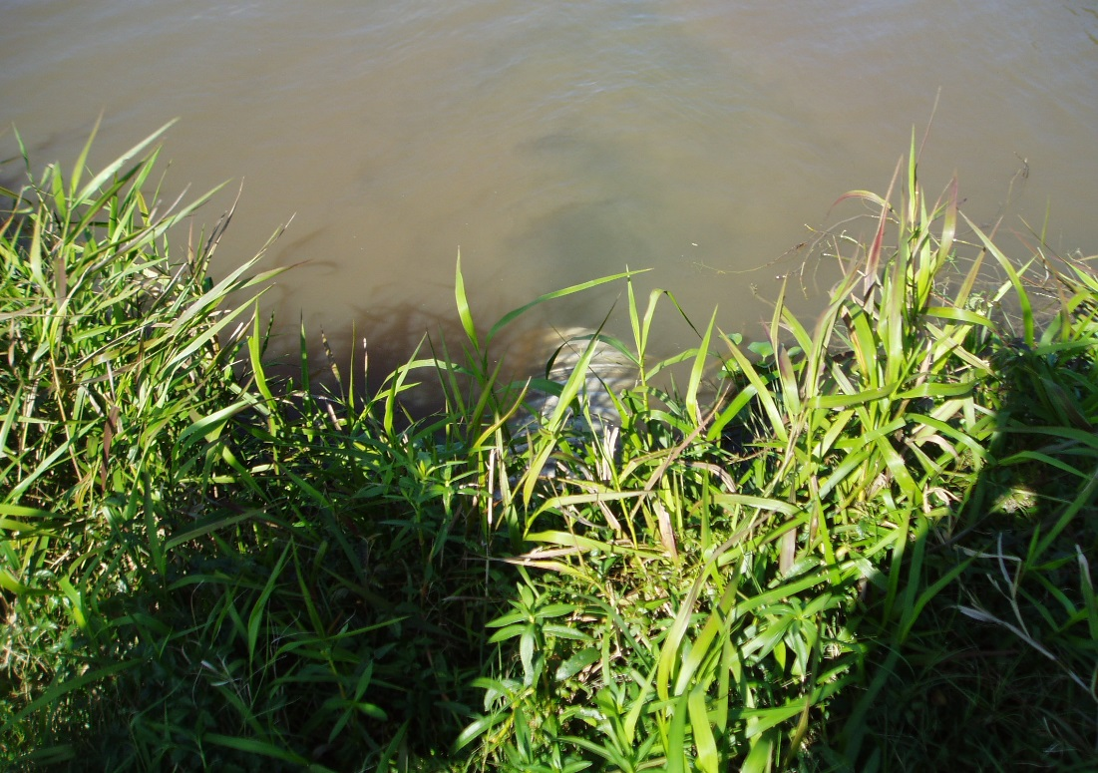
Figure 7-5 Straight pipe discharge East Fork

Agricultural Programs
The Watershed Coordinator will form a partnership with the existing Lone Star Healthy Streams (LSHS) program and Extension service to bring their nonpoint source promotional materials to the Double Bayou Watershed Partnership. The LSHS program focuses on the protection of Texas waterways from bacterial contamination that results from the nonpoint source runoff of bacteria from livestock and feral hog sources.
The program has specific existing materials detailing the nonpoint source runoff management of bacteria and nutrients for beef and dairy cattle, horses, poultry and feral hogs. A recommended management measure is having copies of the Lone Star Healthy Streams materials for horse, feral hogs and cattle available for distribution in the watershed. The stakeholders noted that similar educational materials should be developed for goats. The Watershed Coordinator will work with Extension to provide stakeholders with existing educational materials for goat management and determine if additional materials need to be developed. The existing Lone Star Healthy Streams manuals and the developed materials on goats should be develop for both Spanish and English-speaking audiences.
Stakeholders suggested soil testing and nutrient management as management measures; these would be led by the Watershed Coordinator partnered with Extension. The soil testing campaign may offer soil testing at a reduced rate. An analysis of the soil’s nutrient content will guide proper fertilizing rates for a specific plot of pasture or hay field. The soil testing provides knowledge for the landowner, but it is up to the landowner to decide how to use that knowledge. The nutrient management campaign will provide information on proper agricultural nutrient management through the use of existing Extension materials. This program highlights the importance of proper fertilizer application to reduce the nutrients in nonpoint source runoff into the bayou. Agriculture field days could also be hosted by the Watershed Coordinator and Extension.
The stakeholders suggested that agriculture waste pesticide collection days be held; these would be organized by the Watershed Coordinator in partnership with the TCEQ. The agricultural waste pesticide days would allow land owners to bring their extra pesticides and fertilizers in for disposal without facing any penalties or cost. The waste collection days would also provide an outreach opportunity to share educational materials with stakeholders. In addition, the stakeholders suggested that materials or a workshop on proper and targeted herbicide use be implemented.
The Watershed Coordinator will be able to promote many of the agricultural initiatives in partnership with the WQMP technician (see Chapter 6: Management Measures for a discussion on the WQMP technician). The two positions could organize and host workshops, including some of the activities that Extension offers, such as the Lone Star Healthy Streams programs.

Recreation Programs
To reduce the amount of water quality impairments stemming from recreational activities in the watershed, two flagship outreach and education recreation programs were recommend by the stakeholders. First, an Illegal Boater Dumping Awareness campaign was suggested. This campaign would form a partnership with GBF. The Watershed Coordinator, along with GBF, will promote the Galveston Bay Action Network to prevent and report illegal boater discharges. The Watershed Coordinator will also work with GBF to promote proper recreational boating and boat pump-out practices with boaters who embark from the west side of Galveston Bay and come to recreate in the Double Bayou watershed. One outreach and education management measure that could aid in this process is to add icons for existing park restrooms in and near the watershed to local maps and websites to promote the use of these facilities.
A proper disposal of carcasses awareness event and campaign signage program was suggested as the second cornerstone for the recreational outreach and education measures. This program would inform stakeholders of alternate/proper disposal sites. The program will highlight the proper disposal of carcasses away from waterways to prevent fecal bacteria from entering the waterways of the watershed. The Watershed Coordinator will organize an educational event and provide educational materials on the proper disposal of carcasses to hunters at point-of-sale locations for hunting supplies and licenses. The point of sale displays will also promote the Operation Game Thief program and hunter education.
The stakeholders also recommended that the Watershed Coordinator organize efforts to raise awareness of the pollutant potential of older boat engines and encourage newer boat engines when opportunities arise. Additionally, the Watershed Coordinator will organize efforts to raise awareness on how to reduce the amount of sedimentation stemming from erosion caused by the loss of vegetation from unauthorized ATVs.
In order to meet all of the recreational outreach and education objectives set in this chapter, the stakeholders recommend that the Watershed Coordinator work with the TPWD officers of Chambers and Liberty counties to gain attention for the Illegal Boater Dumping and Proper Disposal of Carcasses campaigns. In addition to these outreach and education measures, the stakeholders suggested that a continuous advertisement be circulated in the Anahuac Progress and Liberty Vindicator newspapers to inform watershed residents of the impacts that dumping carcasses and illegal boater waste has on the water quality of the bayous. To further market and promote proper recreational activities in the watershed, all information and developed materials will be made available on the ChambersWild website. The stakeholders also recommended that younger residents be included in these campaigns and that age-encompassing and appropriate materials be developed for distribution to local schools.

Residential Programs
The stakeholders agreed that the promotion of County landfill facilities that are available for residents could help to reduce the amount of solid waste dumped in the bayou. They suggested there could be a program to include funding to subsidize the tags required by the County for a household to use the landfill as an incentive.
The residents suggested demonstrations of rain gardens and rain water harvesting could be useful. This could promote the use of drain chains or similar at gutter downspouts to drain into rain gardens and decrease bacterial loads into the bayous from concentrations of scavengers.

Wildlife and Non-domestic Plant/Animal Programs
The Watershed Coordinator will work with Extension to bring their extensive outreach and education materials covering the management of feral hog populations to the Double Bayou watershed. These materials will be adopted by the Double Bayou Watershed Partnership. The materials will be displayed at local events, such as Gatorfest and the Boat Parade, and be made available on websites, such as those of ChambersWild and the Double Bayou Watershed Partnership. In addition, Extension’s Feral Hog Management Workshop will be offered for the Double Bayou Watershed. The feral hog outreach and education materials will focus on providing information highlighting how the feral hog population contributes to nonpoint source bacteria pollution to the Bayou.
A Don’t Treat or Feed as Pets campaign will incorporate watershed signage at public access points and possibly a billboard to inform stakeholders not to feed wildlife and help to reduce their concentrations, especially waterfowl (Figure 7-6). Other outreach and education materials will be developed to inform stakeholders of the potential pathways that invasive species are spread, such as transfer by not washing boats when they are used in multiple waterbodies.
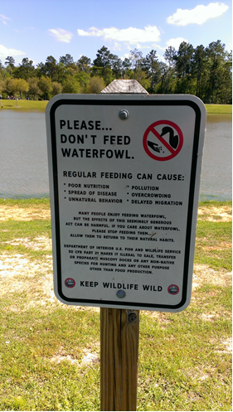
Figure 7-6 Example signage

Litter and Dumping Programs
Stakeholders recommended that an Illegal Solid and Hazardous Waste Dumping Campaign be launched watershed-wide (Figure 7-7). The campaign will incorporate no littering or dumping signage at parks and other recreational hotspots in the watershed. It will also include an informational exhibit at the Anahuac public library. A major component of the Illegal Solid and Hazardous Waste Dumping Campaign will be promoting the use of the Galveston Bay Action Network to report illegal dumping events.
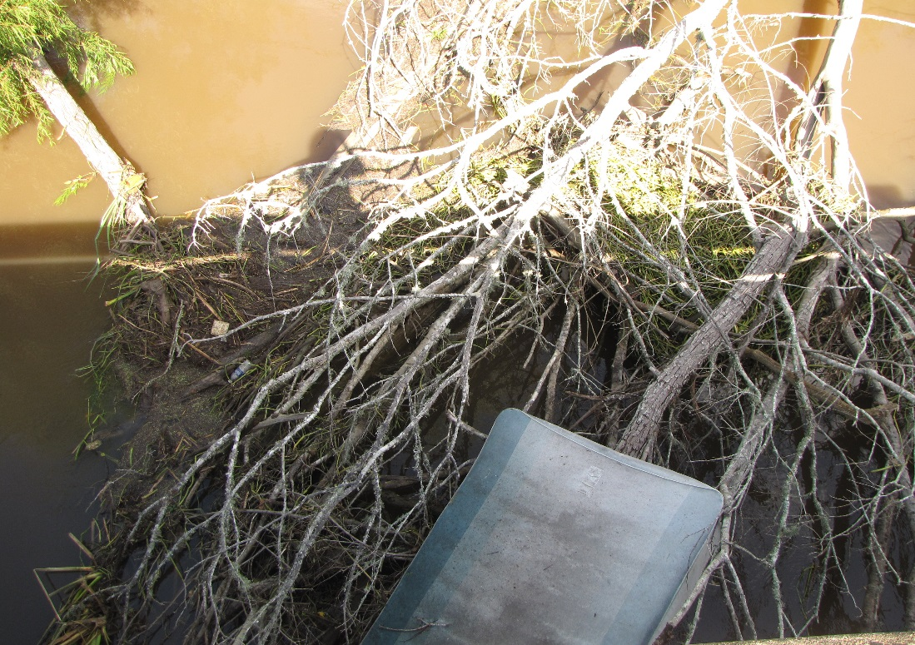
Figure 7-7 Illegal dumping in the watershed
As part of the Illegal Solid and Hazardous Waste Dumping Campaign, the stakeholders suggested that clean-up days be held for the Double Bayou Watershed in the form of Trash Bash. The cleanup event would also provide an opportunity for watershed awareness and stakeholder education. An Adopt-a-Beach program was recommended in the watershed for stakeholders or local businesses to participate and be responsible for picking up litter along a stretch of waterway. Monofilament collection receptacles at bridges and popular fishing destinations could help to educate and collect excess monofilament line. The Texas Sea Grant program already installs and maintains receptacles around Galveston Bay. The Double Bayou Watershed Partnership would attempt to include the Texas Sea Grant as a partner of the campaign.

