Water Quality

Water Quality Sampling
Physical and chemical water quality sampling was conducted to assess the water quality impairments and current conditions of the Double Bayou watershed. All water quality sampling was conducted under an approved Quality Assurance Project Plan (QAPP). Through a process of stakeholder input and scouting for safety/feasibility of sampling, a total of five sampling stations were identified; four mainstem sampling sites and one wastewater treatment facility sampling site (Figure 4-1 USGS sampling station). There are two sampling sites on the East Fork: the East Fork Upper (EFU 08042546) and East Fork Lower (EFL 08042548). These stations are located at FM 1663 (EFU) and at Carrington Road (EFL), respectively. There are two West Fork sampling sites: the West Fork Upper (WFU 08042554) and West Fork Lower (WFL 08042558). These stations are located at Sykes Road (WFU) and Eagle Ferry Road (WFL), respectively. The wastewater treatment facility (WWTF 294443094401100) sampling station was incorporated into the sampling design to characterize a possible point source contribution in the watershed by analyzing the water quality of the effluent discharge of the WWTF (Figure 4-2 Double Bayou sampling stations).
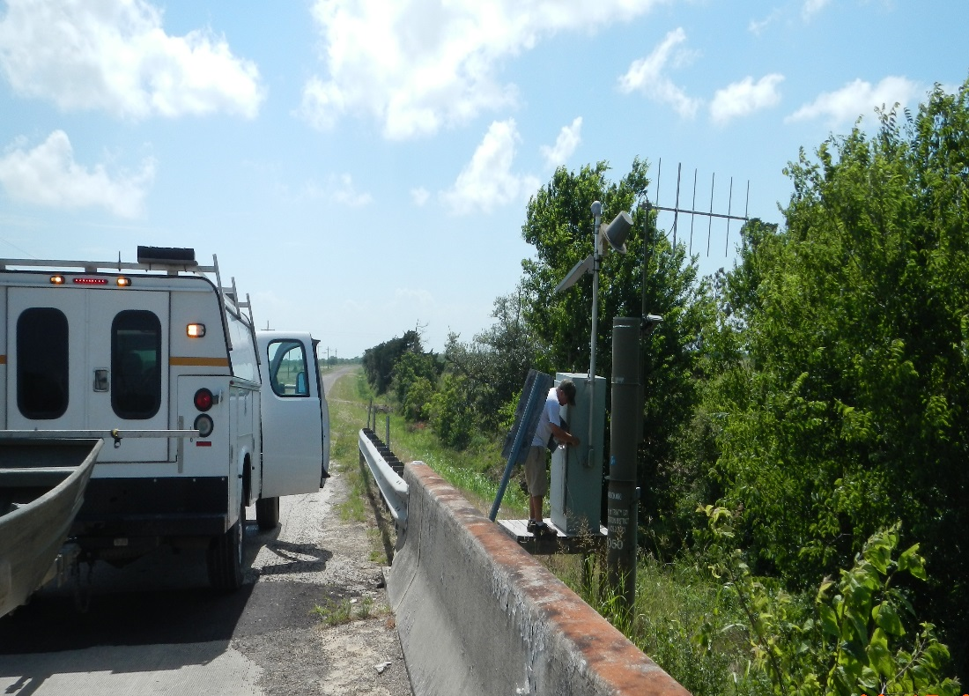
Figure 4-1 USGS sampling station
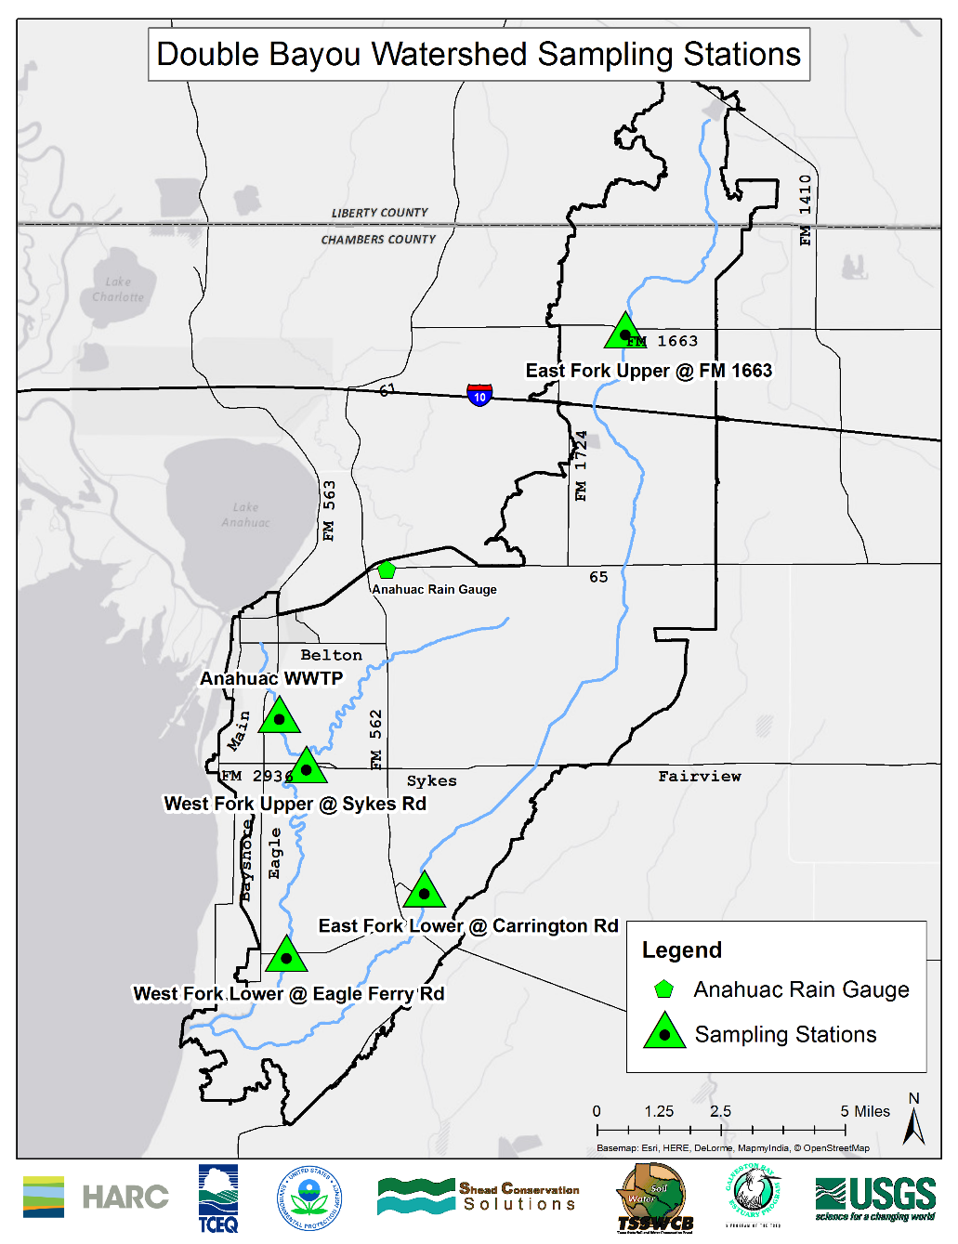
Water quality sampling was conducted under “routine” conditions; that is, these were scheduled events to monitor standard ambient conditions. Water quality sampling was also conducted under “targeted” conditions; that is, these were targeted rain events to monitor impact of rainfall on water quality. The routine samples were collected approximately twice a month over a 19 month sampling period (10/22/2013-05/20/2015) while targeted samples were dependent on rainfall events. 37 to 38 water quality samples were collected at each of the five sampling stations, resulting in a total of 154 routine samples during 30 to 31 sampling events and 35 targeted samples during 7 wet weather sampling events. 38 and 37 samples were collected at the EFU and WWTF stations, respectively, while 113 samples were collected at the tidally influenced stations EFL (38 samples), WFU (38 samples) and WFL (37 samples). All water quality samples analyzed or otherwise included in this WPP are surface water samples collected at 0.3 meters in depth.
Figure 4-2 Double Bayou sampling stations
Targeted flow monitoring attempts to capture peak discharge from rainfall events which can be used to analyze water quality in the bayous during a wet weather event (Table 4-1 Targeted sampling dates). This analysis provides insight on how the increased nonpoint source runoff affects the bayous during rain events. These samples often show the “worst-case” scenario for water quality indicators such as bacteria. The targeted samples should not be considered representative of the bayous water quality during normal flow patterns. Targeted samples are not used to determine listings on the Texas Integrated Report.
Targeted Sampling Date | Amount of Rainfall | Number of Days Since Last Rainfall
10/31/2013 | 0.53 | 2
2/26/2014 | 2.50 | 1
5/13/2014 | 1.10 | 27
5/27/2014 | 0.16 | 12
9/17/2014 | 1.40 | 0
3/10/2015 | 0.40 | 0
4/17/2015 | 2.80 | 0
Table 4-1 Targeted sampling dates
All other sampling events are considered routine samples regardless of the amount of precipitation that occurred on or before the sampling day. Although routine samples that were collected in accordance with a wet weather event can also be helpful to assess the condition of the bayous during rain events. The routine samples are used to assess baseline water quality conditions in the watershed.

Stream Type Designations and Tidal Mixing
Throughout this WPP all referenced stream type designations such as tidal and nontidal will include a combination of the stations with the corresponding stream type designation (Table 4-2 Stream type designations), unless otherwise specified. For the purposes of this WPP, when bacteria is mentioned in association with a sampling station it will be in reference to E. coli at the nontidal stations EFU and WWTF. The other three stations are assessed using Enterococci.
Sampling Station | Sampling Station ID | Stream Type
Wastewater Treatment Facility | 2.94443E+14 | Nontidal
East Fork Upper | 8042546 | Nontidal
East Fork Lower | 8042548 | Tidal
West Fork Upper | 8042554 | Tidal
West Fork Lower | 8042558 | Tidal
Table 4-2 Stream type designations
Although the Anahuac Ditch, where the WWTF sampling station is located, forms its confluence with the main tidal portion of the West Fork of Double Bayou, the ditch itself is classified as a nontidal freshwater stream. The only other nontidal sampling station selected for monitoring is the EFU station. The remaining three sampling stations are designated as tidal. The WFL station has the strongest negative discharge measured during the sampling period. A negative discharge is defined as discharge moving from downstream towards upstream, caused by an incoming tide from Trinity Bay. Over the 10 month study period, the strongest tidally influenced negative discharge recorded at the WFL station was -207 cubic feet per second (cfs). Comparatively, the EFL station registered -49 cfs as its strongest tidal discharge; while a maximum discharge of -70 cfs was recorded at the WFU station. The degree of tidal influence is also evident in the disparity of the average salinity regime at the different sampling stations (Table 4-3 Mainstem stations average salinity).
Station | Average Salinity (PSU)
East For Upper | 0.14
East Fork Lower | 0.89
West Fork Upper | 0.21
West Fork Lower | 6.86
Table 4-3 Mainstem stations average salinity
See Chapter 5, Section 5.9.1 Tidal Influence, for a detailed discussion on tidal mixing and how it affects constituents compared to typical nontidal flow.

Precipitation
The Anahuac rain gauge has been operational since March of 1931 and is located east of the City of Anahuac (Figure 4-2 Double Bayou sampling stations). The precipitation data were downloaded from NOAA’s online climate data portal and used for analysis. The data were analyzed to determine the number of days since last rainfall, which can provide valuable insight to the effects of rainfall on nonpoint source runoff into the bayou.
Precipitation analysis is crucial when analyzing water quality data, as the impact of rain events can impact water quality results (Figure 4-3 Precipitation in Double Bayou). Larger rain events increase surface runoff, which can result in larger amounts of nonpoint source pollutants flowing into the bayous. The amount of time between rain events can also impact water quality results. Typically, as the amount of days since last rainfall (DSLR) increases, higher levels of nonpoint source pollutants can be washed into the bayou because the pollutants accumulate on the ground during the period of no rain. A combination of greater length of DSLR followed by an intense wet weather event can intensify the impact on the concentrations of nonpoint water quality pollutants in the bayous.
An example of this in Double Bayou was the sampling event on 5/13/2014. Prior to this targeted sampling event, 27 days had passed since the last rainfall. On 5/13/2014, 1.10 inches of rain was received. The combination of the large wet weather event and great amount of DSLR can lead to high bacteria contributions that are flushed into the bayous because the bacteria is allowed to build before being effectively flushed by the large precipitation event.
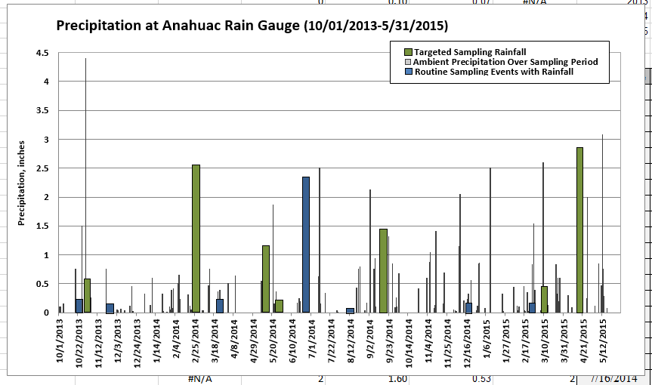
Figure 4-3 Precipitation in Double Bayou

Dissolved Oxygen
Dissolved oxygen (DO) is a commonly monitored water quality indicator that is crucial for the survival of all aquatic life. The concentration of dissolved oxygen in a waterbody is typically considered optimal for aquatic life at concentrations above 6 mg/L; aquatic organisms will become stressed at concentrations between 4 and 5 mg/L; and the loss of aquatic life is probable below 3 mg/L. The criterion used by the TCEQ to determine if a waterbody is impaired is below 3 mg/L, which is based on the increased stress on aquatic organisms below this threshold. The DO criterion is unique because the sample must be less than the threshold of 3 mg/L to be considered as an exceedance compared to most other water quality indicators which have to exceed the designated criterion.
The concentration of DO in a waterbody can fluctuate depending on several environmental factors including the temperature and salinity of the water and the time of day. Due to temporal variations, DO can fluctuate from season to season. The lowest DO levels are typically observed during the hottest months of the year while the highest DO levels are during the coldest time of the year, because colder water can hold more dissolved oxygen. Over the sampling period (10/22/2013-5/20/2015), the average concentration of DO in the Double Bayou watershed (all stations) was 6.2 mg/L. The highest DO concentration was 12.6 mg/L while, the lowest was 0.8 mg/L. During the sampling period, 18 routine and targeted samples (10%) were below the TCEQ criterion of 3 mg/L (Figure 4-4 Double Bayou dissolved oxygen results). The EFU station had the highest percentage of samples below the TCEQ criterion at 29%. No dissolved oxygen samples below the criterion were recorded at the WWTF station while 2 were recorded at the EFL station, 4 at WFU and 1 at WFL.
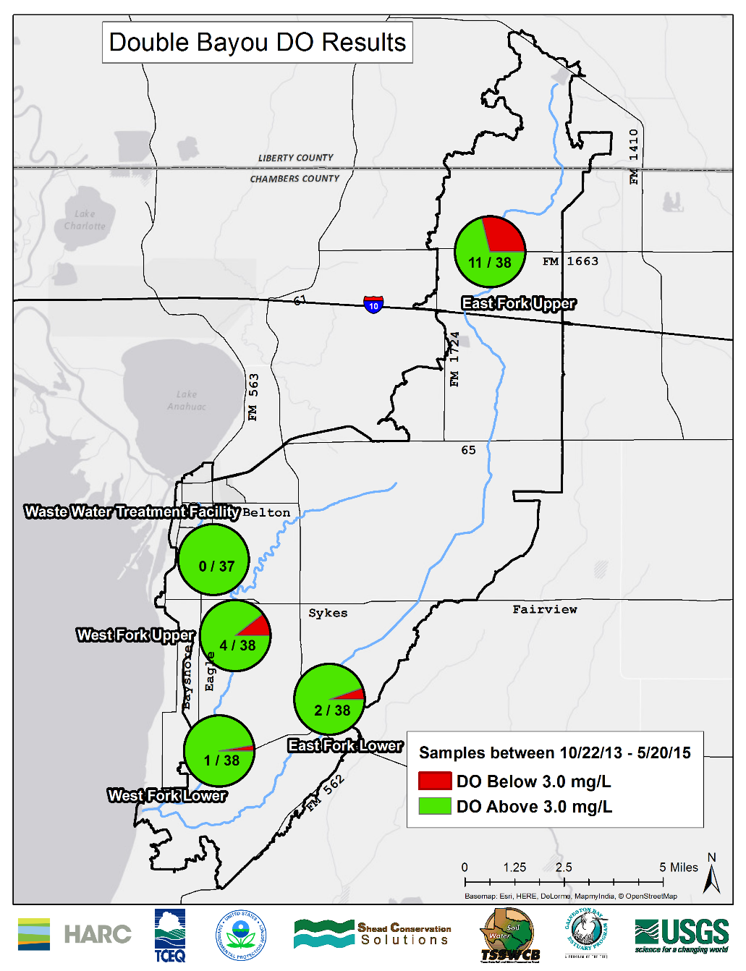
Figure 4-4 Double Bayou dissolved oxygen results
Dissolved oxygen is a not a pollutant but rather a marker to indicate water quality and health for aquatic life. Low dissolved oxygen can be due to a number of other factors in the bayous. One factor can be high bacteria levels, since an increase in bacteria will often lead to higher consumption of oxygen which will result in low dissolved oxygen levels. The water quality management measures discussed in Chapters 6 and 7 will be targeted towards bacteria, but their benefits will also extend to mitigating lower dissolved oxygen levels.

24-hour Dissolved Oxygen Sampling
In addition to the targeted and routine sampling, twelve 24-hour multi-probe soaks were recorded at the mainstem sampling stations EFU, EFL, WFU and WFL (Table 4-4 24-hour monitoring events). Continuous (24-hour) monitoring data (water temperature, specific conductance, dissolved oxygen, pH) were collected at 15 minute intervals at each sampling station of East and West Fork Double Bayou during 24-hour events. 24-hour DO monitoring is measured to determine compliance with aquatic life use designations and support biological modeling, as well as aid with short-term temporal fluctuation analyses. The 24-hour monitoring can show the variation of dissolved oxygen throughout the course of the day and reveal the high and low dissolved oxygen concentrations.
Station | Start |  | End |  | Total Hours
 | Date | Time | Date | Time
EFU | 8/20/2014 | 15:00 | 8/21/2014 | 15:00 | 24
WFU | 8/20/2014 | 13:15 | 8/21/2014 | 14:30 | 25.15
EFU | 9/17/2014 | 14:00 | 9/19/2014 | 10:30 | 40.5
WFU | 9/17/2014 | 12:30 | 9/19/2014 | 11:00 | 42
EFU | 10/14/2014 | 14:45 | 10/15/2014 | 14:30 | 23.45
WFU | 10/14/2014 | 13:30 | 10/15/2014 | 13:45 | 24.15
EFL | 12/3/2014 | 10:45 | 12/4/2014 | 12:00 | 25.15
WFL | 12/3/2014 | 10:30 | 12/4/2014 | 10:45 | 24.15
EFL | 2/25/2015 | 12:45 | 2/26/2015 | 14:45 | 26
WFL | 2/25/2015 | 13:30 | 2/26/2015 | 14:30 | 25
EFL | 7/15/2015 | 10:30 | 7/16/2015 | 14:15 | 27.75
WFL | 7/7/2015 | 10:45 | 7/6/2015 | 11:15 | 24.5
Table 4-4 24-hour monitoring events
A separate set of criteria and analyses are used to assess the 24-hour dissolved oxygen monitoring; the absolute minimum and average value are determined from a continuous 24-hour monitoring event. The TCEQ also requires a minimum amount of samples to be taken during specific seasons (index periods) to accurately represent seasonal dissolved oxygen variations. These values must then meet certain TCEQ requirements to determine if the waterbody is impaired. 24-hour sampling events are resource intensive and therefore 24-hour data are not always available at all streams during the index period necessary for criteria analysis. If the 24-hour sampling events are not available, TCEQ relies on grab sample DO data as described above for assessment. Both 24-hour data and grab samples have been used for West and East fork assessments. The criterion to assess the aquatic life use for 24-hour nontidal (freshwater) average is 5.0 mg/L, average 24-hour tidal (saline water) is 4 mg/L and the 24-hour minimum criterion for tidal and nontidal waters is 3.0 mg/L. The 24-hour data discussed below represent sampling efforts not specifically within the TCEQ criteria for index periods; the data analyzed represent diurnal dissolved oxygen patterns which are important in assessing the health of the watershed.
All three of the East Fork Upper nontidal 24-hour monitoring events were below the average and minimum dissolved oxygen TCEQ criteria of 5.0 mg/L and 3.0 mg/L, respectively. The East Fork Lower 24-hour monitoring event on 12/3/2014 was below the minimum standard. Two of the West Fork Upper 24-hour monitoring events were below the minimum and average criterion on 8/20/2014 and 9/17/2014 none of the West Fork Lower 24-hour monitoring events resulted in samples below the TCEQ criterion.

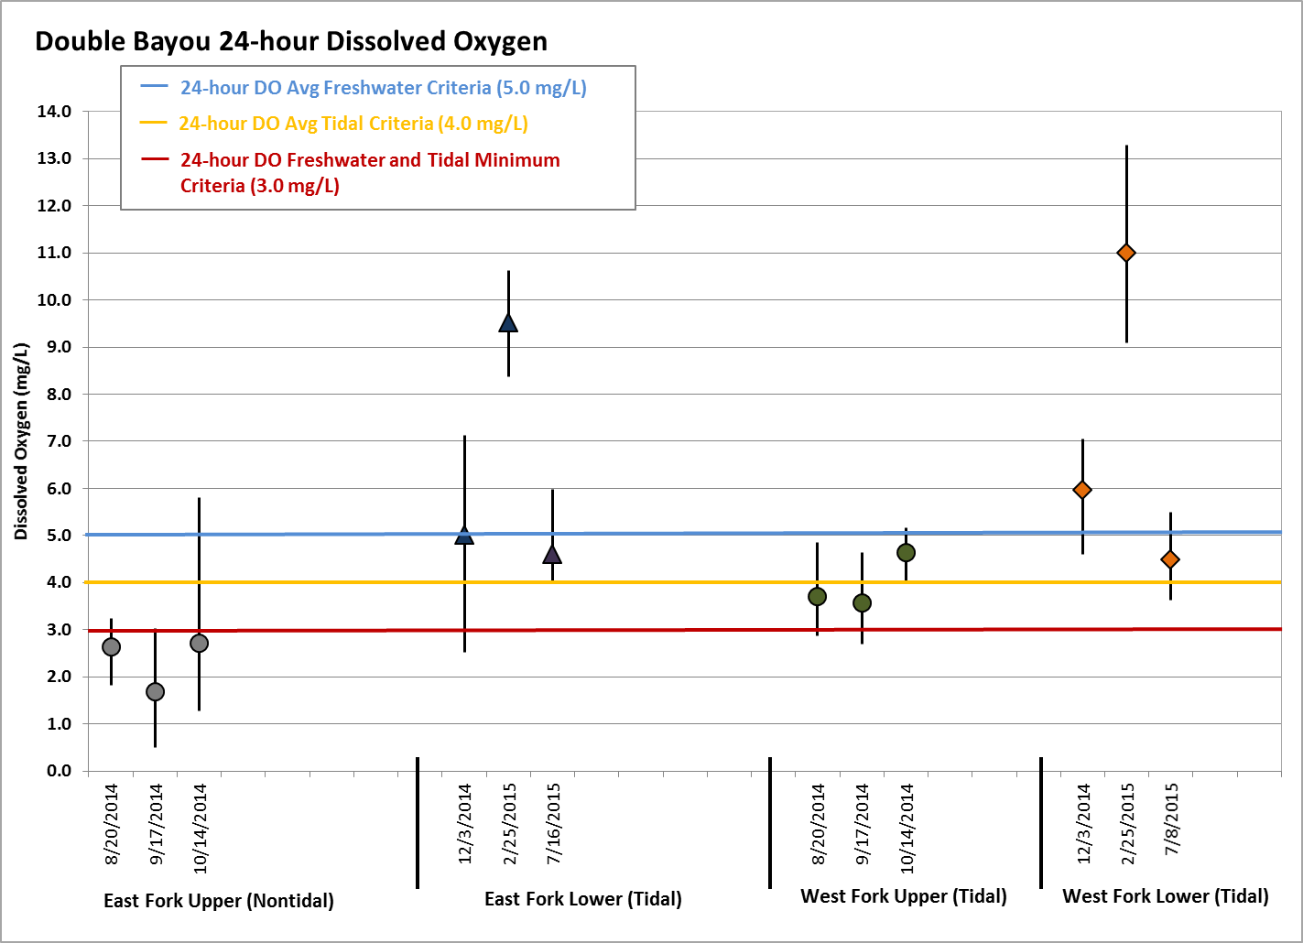
Figure 4-5 24-hour dissolved oxygen

Bacteria
Another critical indicator of nonpoint source pollution in the Double Bayou watershed is bacteria; specifically, the fecal indicator bacteria E. coli and Enterococci. E. coli is the preferred nontidal (freshwater) fecal indicator bacteria and was used for analysis in the upper nontidal reaches of the East Fork and at the nontidal WWTF to assess bacteria concentrations. E. coli was utilized at the WWTF station instead of Enterococci because the WWTF NPDES permit also uses E. coli; a direct comparison can be made. The preferred tidal (saline) waters fecal indicator bacteria is Enterococci (TCEQ 2010). These bacteria are the preferred indicator bacterium to determine the level of health risk of fecal contamination and associated pathogens in their respective waterbodies. The effluent E. coli concentrations are also monitored by the Anahuac WWTF as a stipulation to self-report under their NPDES permit. The fecal indicator bacterium are not a primary threat to human health, but serve as an indicator for potential harmful pathogenic microorganisms and fecal waste contamination. The presence of bacteria can indicate other impacts on the water body such as a high level of inorganic nutrients (i.e. nitrogen and phosphorus).
Typically, two different benchmarks are utilized by TCEQ to determine the bacteria impairments of a water body. The first method, known as a single sample benchmark, can be utilized to assess a one-time grab sample or multiple grab samples over a period of time (Figure 4-6 Single sample bacteria exceedances). The single sample benchmark of 394 MPN/100 mL was used for E. coli at the EFU and WWTF nontidal stations while the single sample benchmark of 89 MPN/100 mL was used for Enterococci at the EFL, WFU and WFL sampling stations (TCEQ 2010). (Note that bacteria units are typically identified as colony forming units (cfu) or most probable number (mpn) according to the lab method used for analysis; during our sampling period, bacteria were identified in the lab in units of mpn and this discussion will reflect that. The SELECT model (Chapter 5, Section 5.3) uses cfu for bacteria units; these units reflect the same in terms of amount of bacteria.) The number of samples that exceed the appropriate benchmark is often depicted as a percent exceedance, which equals the total number of samples at the sampling station divide by the number of samples that exceed the bacteria benchmark. Because rain events have a high degree of influence on the bacteria concentrations in the bayou the bacteria data is typically subdivided into the two sampling categories; routine and targeted for separate analysis.
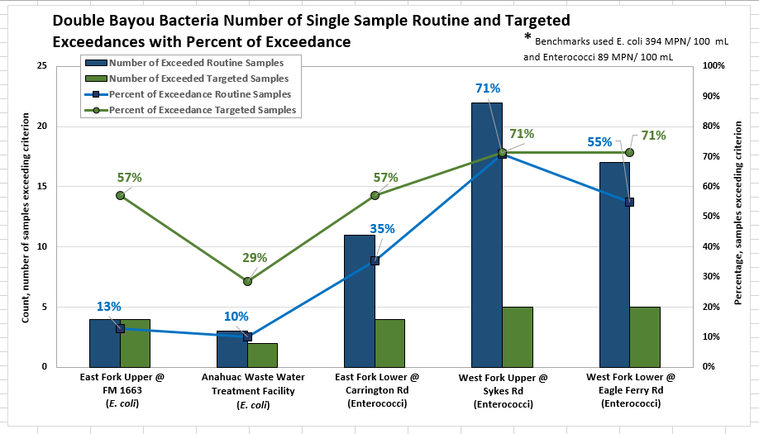
Figure 4-6 Single sample bacteria exceedances
The nontidal sampling station with the most number of bacteria exceedances was the EFU station with 4 routine and 4 targeted single sample E. coli benchmark exceedances. 13% of the routine samples and 57% of targeted single samples collected at the EFU station were over the TCEQ benchmark of 394 MPN/100 mL. The WFU station had the highest percent of exceedance (71%) for routine Enterococci monitoring. The tidal targeted sampling percent of exceedance was highest (71%) at both the WFU and WFL stations while the EFL had the fewest number of routine and targeted tidal exceedances at 35% and 57%, respectively. Figure 4-6 reveals that the percent of exceedance for the targeted samples was higher than the percent exceedances of routine samples at all of the Double Bayou monitoring stations for the duration of the sampling period.
The second benchmark that is often used to analyze bacteria concentrations is a geometric mean; this analysis typically includes multiple samples over a longer time period (Figure 4-7 Bacteria geometric means). The TCEQ uses a geometric mean based criterion to indicate bacteria impairments for recreational waterbodies. The geometric mean was also used to conduct bacteria analysis for this WPP because the geometric mean is a type of average that normalizes the sampling data over a period of time. The geometric mean criterion for E. coli is 126 MPN/100 mL while the geometric mean criterion for Enterococci is 35 MPN/100 mL (TCEQ 2012). These benchmarks are based on the TCEQ’s primary contact (i.e. swimming, water skiing and surfing) standards for reactional waterbodies. Targeted samples are not included in the geometric mean calculations.
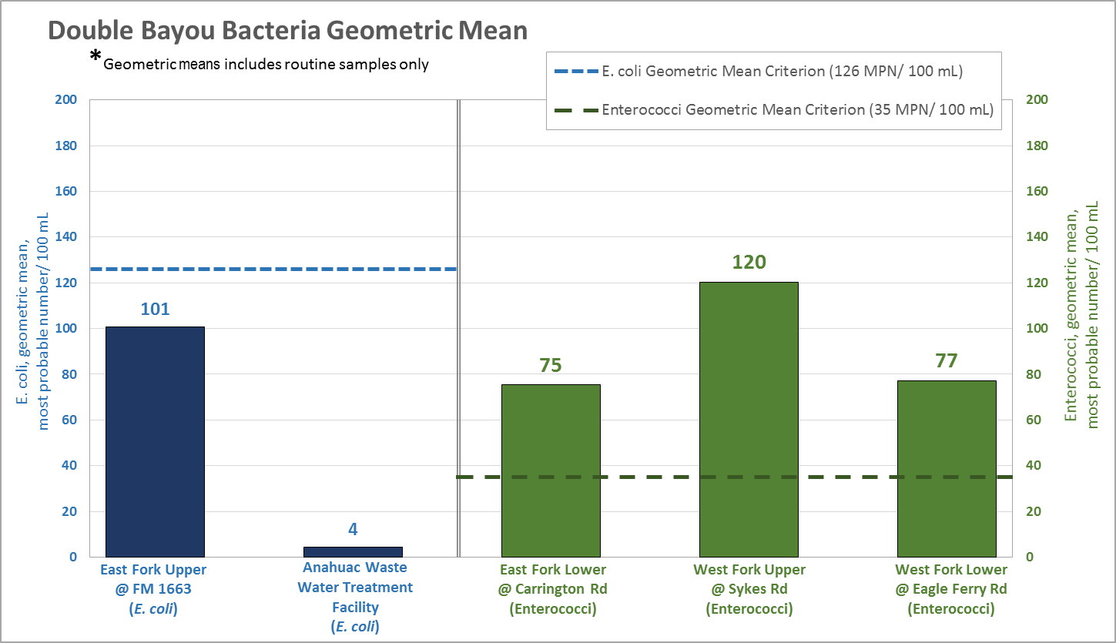
Figure 4-7 Bacteria geometric means
All three of the Double Bayou tidal monitoring stations exceeded the geometric mean benchmark for Enterococci (35 MPN/100 mL). Of the three tidal stations the WFU had the highest geometric mean while the EFL station had the lowest. The EFU station did not exceeded the geometric mean benchmark for E. coli (126 MPN/100 mL). In addition, the WWTF station has a geometric mean significantly lower than the benchmark.
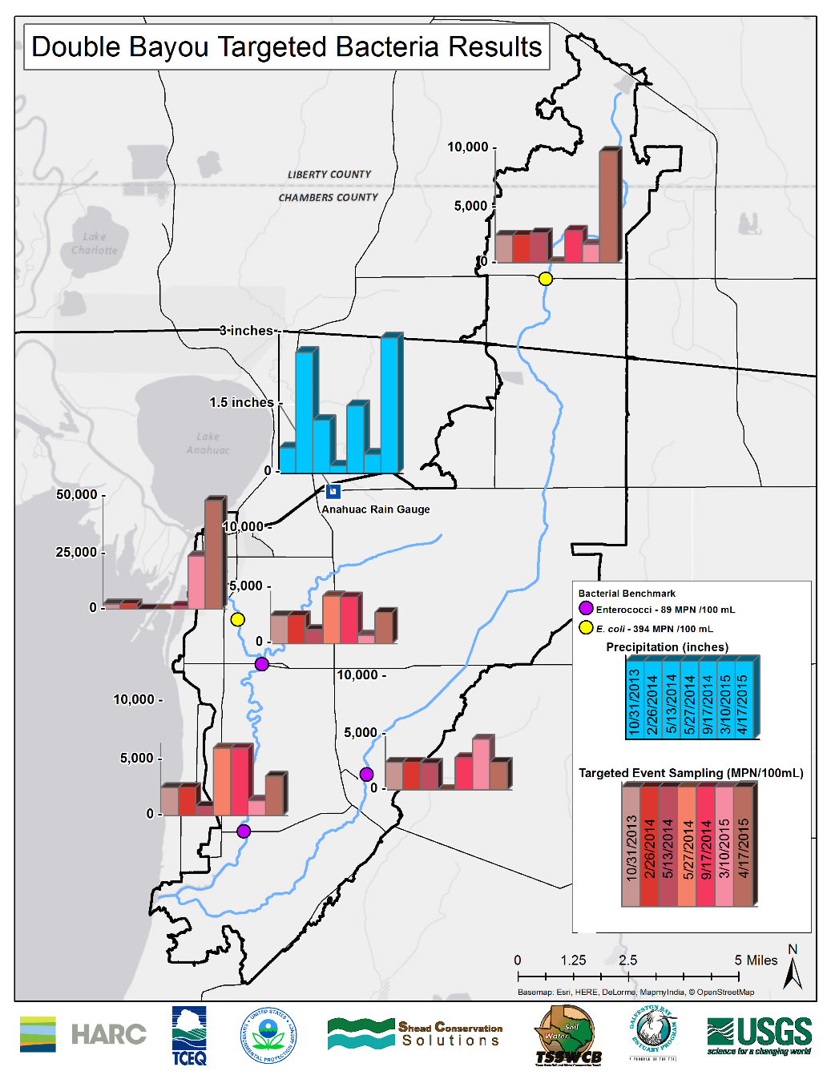
Figure 4-8 Targeted bacteria sampling results
The largest targeted rainfall event (2.80 inches) occurred on 4/17/2015; however, 0 days had passed since the last rainfall; 2.50 inches of rain was also received over the five days prior to the 4/17/2015 rain event (Figure 4-8 Targeted bacteria sampling results). The highest concentration of targeted sampling E. coli was recorded at the WWTF (49,000 MPN/100 mL) and at the EFU (9,600 MPN/100 mL) sampling stations during this rain event. However, the remaining three stations did not receive their highest amount of bacteria nonpoint source runoff during the most intense rain event.

Nutrients and Chlorophyll-a
Nutrients and their associated indicator of algae biomass, Chlorophyll-a, are the third class of indicator used to determine if excessive nonpoint source pollution is prevalent in Double Bayou. Chlorophyll-a is a green pigment found in plants that absorbs sunlight and converts it to sugar during photosynthesis using nutrients such as phosphorus and nitrogen. High levels often indicate poor water quality and low levels often suggest good conditions but it is the overall cycle that is important. However, long-term persistence of elevated levels can be problematic. Chlorophyll-a is often used as an indicator of phytoplankton abundance and biomass in coastal and estuarine waters.
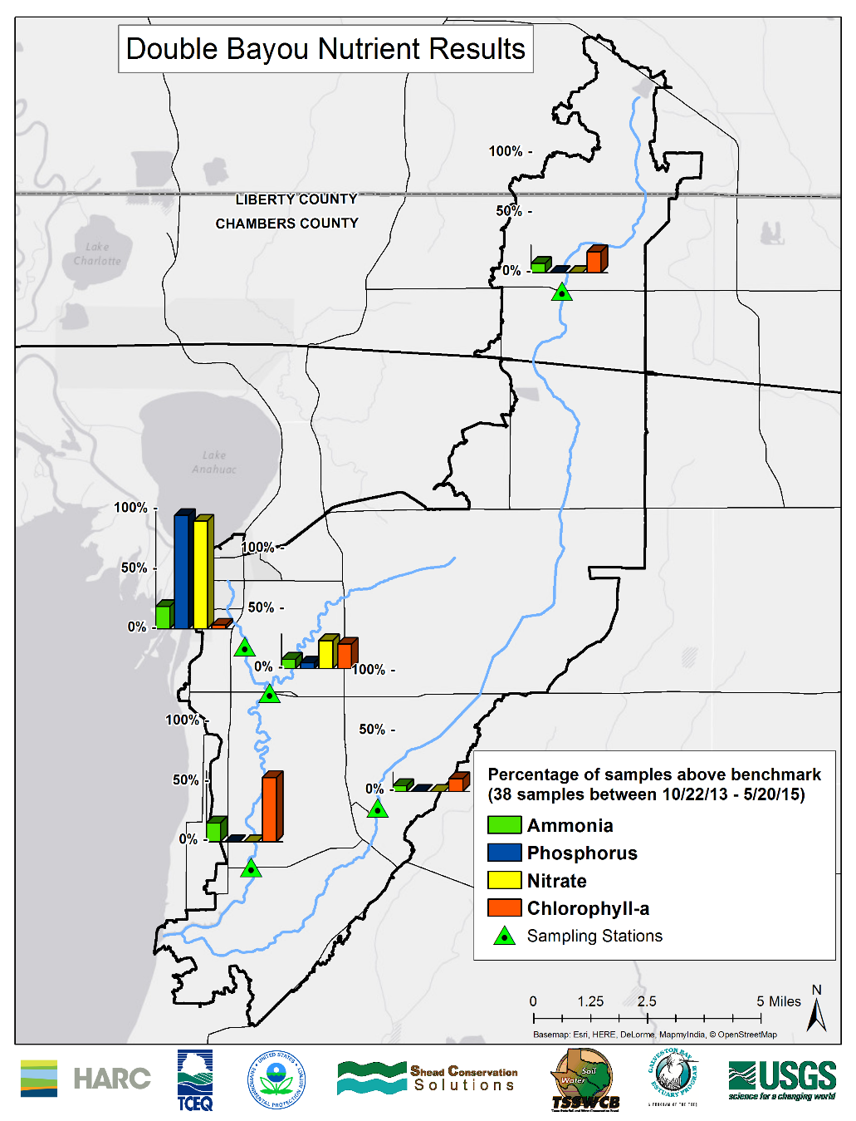
Figure 4-9 Nutrient percent of exceedance
Among the various forms of nitrogen sampled by the USGS, nitrate, orthophosphate, total phosphorus and ammonia were chosen for analysis. It is important to monitor these nutrients because excess concentrations can lead to eutrophication. Eutrophication occurs when excessive nonpoint source nutrients fuel a phytoplankton bloom. This bloom can only be supported for a short period of time until large amounts of the phytoplankton die off in unison and sink to the bottom of the water column. Their subsequent decomposition uses up available dissolved oxygen and depresses oxygen levels. The decreased oxygen levels can lead to die off of organisms such as fish and invertebrates. These organisms then sink to the underlying hypoxic zone and use more oxygen as they decompose. This exacerbates the hypoxic conditions and continues to suppress oxygen levels eventually rendering the water body unsuitable for life.
Concerns for general uses are identified with screening levels for nutrients and chlorophyll-a. TCEQ screening levels for nutrients and chlorophyll-a are statistically derived from monitoring data. Double Bayou West Fork was identified as a concern for water quality based on screening levels for chlorophyll-a in the 2012 Texas Integrated Report (TCEQ 2012). It is important to monitor the nutrient levels in Double Bayou to assess the long term nutrient trends. Tracking of the nutrients can serve as early detection if the number of exceedances start to increase or a new activity in the watershed is causing an excessive nonpoint source loading of nitrogen. Over the 19 month study period, the highest percent of exceedances of ammonia, phosphorus and nitrate were at the WWTF station (Figure 4-9 Nutrient percent of exceedance). Chlorophyll-a had the highest percent of exceedance at WFL.

TCEQ (2010). 2010 Guidance for Assessing and Reporting Surface Water Quality in Texas, Texas Commision on Environmental Quality
TCEQ (2012). 2012 Guidance for Assessing and Reporting Surface Water Quality in Texas, Texas Commision on Environmental Quality

